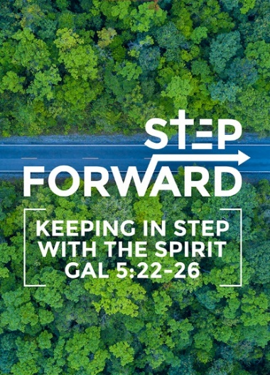
A Nation’s Prayer: Lessons from Daniel’s Prayer (Daniel 9:1-11, 17-19)
Pastor Dato Daniel Ho

In the first year of Darius son of Xerxes (a Mede by descent), who was made ruler over the Babylonian kingdom— in the first year of his reign, I, Daniel, understood from the Scriptures, according to the word of the Lord given to Jeremiah the prophet, that the desolation of Jerusalem would last seventy years. So I turned to the Lord God and pleaded with him in prayer and petition, in fasting, and in sackcloth and ashes. I prayed to the Lord my God and confessed: “Lord, the great and awesome God, who keeps his covenant of love with those who love him and keep his commandments, we have sinned and done wrong. We have been wicked and have rebelled; we have turned away from your commands and laws. We have not listened to your servants the prophets, who spoke in your name to our kings, our princes and our ancestors, and to all the people of the land. “Lord, you are righteous, but this day we are covered with shame—the people of Judah and the inhabitants of Jerusalem and all Israel, both near and far, in all the countries where you have scattered us because of our unfaithfulness to you. We and our kings, our princes and our ancestors are covered with shame, Lord, because we have sinned against you. The Lord our God is merciful and forgiving, even though we have rebelled against him; we have not obeyed the Lordour God or kept the laws he gave us through his servants the prophets. All Israel has transgressed your law and turned away, refusing to obey you. “Therefore the curses and sworn judgments written in the Law of Moses, the servant of God, have been poured out on us, because we have sinned against you. (Daniel 9:1-11)

“Now, our God, hear the prayers and petitions of your servant. For your sake, Lord, look with favor on your desolate sanctuary. Give ear, our God, and hear; open your eyes and see the desolation of the city that bears your Name. We do not make requests of you because we are righteous, but because of your great mercy. Lord, listen! Lord, forgive! Lord, hear and act! For your sake, my God, do not delay, because your city and your people bear your Name.” (Daniel 9:17-19)

Introduction
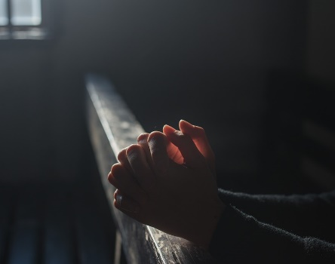
When we project the word of God, it brings power. This is why we project the Word of God in Church. A lady brought a chicken to the church to be prayed for. She said that she wanted to create a legacy for the grandchildren. She asked to pray using the prayer book. When she arrived, the chicken died. When she returned, the pastor said that he prayed from the funeral section. She demanded the pastor to pray from the resurrection section. We need to be careful what we pray for. Prayer is very important but it should be prayer correctly.

Big Idea: We Need to Pray as A Nation

Daniel prayed for his nation. Babylon and the empire is advanced. Watches, ziggurats and mathematics are examples of them. Daniel was shocked. Judah and Jerusalem were far behind. Daniel and his friends raised to the ranks to be leaders of the nations. Never despise small beginnings. Reject the term. How did Daniel start his prayer.

The Premise in Prayer: Based on the Word of God (Daniel 9:1-2)
In the first year of Darius son of Xerxes, who was made ruler over the Babylonian kingdom— in the first year of his reign, I, Daniel, understood from the Scriptures, according to the word of the Lord given to Jeremiah the prophet, that the desolation of Jerusalem would last seventy years. (Daniel 9:1-2)

Daniel was praying from the Word of God. He was praying from the book of Jeremiah

Therefore the Lord Almighty says this: “Because you have not listened to my words, I will summon all the peoples of the north and my servant Nebuchadnezzar king of Babylon,” declares the Lord, “and I will bring them against this land and its inhabitants and against all the surrounding nations. I will completely destroy them and make them an object of horror and scorn, and an everlasting ruin. I will banish from them the sounds of joy and gladness, the voices of bride and bridegroom, the sound of millstones and the light of the lamp. This whole country will become a desolate wasteland, and these nations will serve the king of Babylon seventy years. (Jeremiah 25:8-11)

This is what the Lord says: “When seventy years are completed for Babylon, I will come to you and fulfill my good promise to bring you back to this place. For I know the plans I have for you,” declares the Lord, “plans to prosper you and not to harm you, plans to give you hope and a future. Then you will call on me and come and pray to me, and I will listen to you. (Jeremiah 29:10-12)
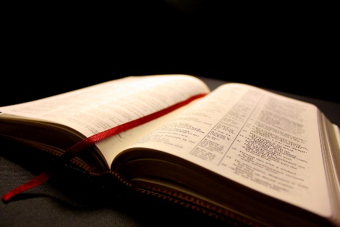
Daniel knows it was coming close to the 70-year exile. He started praying for the nation. Everything is based on the word of God. It explains how it will happen and all the details is explained. On May the 8, DUMC was praying for Malaysia as the next day was the elections. As Pastor Daniel came back, he was asked to share and he shared from Isaiah

Who has ever heard of such things? Who has ever seen things like this? Can a country be born in a day or a nation be brought forth in a moment? Yet no sooner is Zion in labor than she gives birth to her children. (Isaiah 66:8)

The answer to the above was yes. Malaysia needed a change.

The Posture of prayer: Compelled by deep personal brokenness and anguish of heart (Daniel 9:3)

So I turned to the Lord God and pleaded with him in prayer and petition, in fasting, and in sackcloth and ashes. (Daniel 9:3)

Daniel was deeply burdened for Jerusalem grieving over it. Unload to God all your burdens. Before we even pour out to Him we need to proclaim and honour Him.

The Pre-occupation of Prayer

Proclaiming the Honour of God’s name (Daniel 9:4,7,9)

I prayed to the Lord my God and confessed: “Lord, the great and awesome God, who keeps his covenant of love with those who love him and keep his commandments (Daniel 9:4)

Daniel focuses on our great and awesome God. God is in charge. It seems that evil is in control. He is a covenant keeping God. He is a God of love. He will never leave us and forsake us. He will prove that he is always there.

When Pastor Daniel started DUMC full time 6.5 years after working as an engineer. one member approached pastor and asked to sell Amway. Pastor Daniel refused because he believed that “As we take care of God’s house, He is more than able take care of our house”

Lord, you are righteous, but this day we are covered with shame—the people of Judah and the inhabitants of Jerusalem and all Israel, both near and far, in all the countries where you have scattered us because of our unfaithfulness to you. (Daniel 9:7)

Pre-occupation with God’s agenda (Daniel 9:10-11,13)

we have not obeyed the Lord our God or kept the laws he gave us through his servants the prophets. All Israel has transgressed your law and turned away, refusing to obey you. “Therefore the curses and sworn judgments written in the Law of Moses, the servant of God, have been poured out on us, because we have sinned against you. (Daniel 9:10-11)

The purpose of God’s laws is to lead and guide us. Spend time on God’s world, that is His word. The law is a light to our feet and light to our path.

Just as it is written in the Law of Moses, all this disaster has come on us, yet we have not sought the favor of the Lord our God by turning from our sins and giving attention to your truth. (Daniel 9:13)

God’s truth brings us understanding. We know how to live our lives. All truth is God’s truth and it comes from God originality. No other person has claims himself as “the truth” except Jesus. We need to seek and examine whether Jesus’s words are true or not. Frank Morrison did a deep study on whether Jesus resurrected or not. He claimed that Jesus was dead. He travelled and study for three years to prove Jesus dead but he was wrong. There are evidences to prove this.

The truth will set you free. In our experience, we experience change and transformation. There is evidence and experience. There is coherence. Some people bargain with God that they will come to God. When we are in the midst of power and riches, we are blind to the truth.

The Problem in Prayer

Confronted by the true state of the nation (v. 5-7)
we have sinned and done wrong. We have been wicked and have rebelled; we have turned away from your commands and laws. We have not listened to your servants the prophets, who spoke in your name to our kings, our princes and our ancestors, and to all the people of the land. “Lord, you are righteous, but this day we are covered with shame—the people of Judah and the inhabitants of Jerusalem and all Israel, both near and far, in all the countries where you have scattered us because of our unfaithfulness to you. (Daniel 9:5-7)

He recognizes the Israelites mistakes. Daniel uses ‘we’, not ‘they’. He identifies with the sin of his people. We blame the government and other people. We are also responsible. Edmund Burke said, “The only thing necessary for the triumph of evil is for good people to do nothing”. John Stott also says that the church has failed if the society around them fall apart. We need to speak up, change and transform. We unload all problems about Malaysia. Malaysia has the best infrastructure, weather and food. We are really blessed to worship comfortably.

Convinced of the lostness of man and the nation (Daniel 9:11b, 12)

All Israel has transgressed your law and turned away, refusing to obey you. “Therefore the curses and sworn judgments written in the Law of Moses, the servant of God, have been poured out on us, because we have sinned against you. You have fulfilled the words spoken against us and against our rulers by bringing on us great disaster. Under the whole heaven nothing has ever been done like what has been done to Jerusalem. (Daniel 9:11-12)

“The Billion Dollar Whale” was a sad depiction of what transpired. There are 2 families affected by MH 370. We must come before God and crying to Him.

The petition in prayer: Looking to God for mercy and grace (Daniel 9: 17-19; 2 Chron. 7:14)

“Now, our God, hear the prayers and petitions of your servant. For your sake, Lord, look with favor on your desolate sanctuary. Give ear, our God, and hear; open your eyes and see the desolation of the city that bears your Name. We do not make requests of you because we are righteous, but because of your great mercy. Lord, listen! Lord, forgive! Lord, hear and act! For your sake, my God, do not delay, because your city and your people bear your Name.” (Daniel 9:17 -19)

As we pray for Malaysia, we must pray in humility for God to listen, forgive, hear and act for God’s name.

if my people, who are called by my name, will humble themselves and pray and seek my face and turn from their wicked ways, then I will hear from heaven, and I will forgive their sin and will heal their land. (2 Chronicles 7:14)

This passage gives us the authority as spiritual leaders to call God from heaven to heal the nation.

Conclusion

We were given nationhood on 31st August 1957. In 2007, it was a year of Jubilee. Pastor Daniel called for a day of prayer walk. Pastor went to the place where May 13, 1969 started with three people. As they prayed to break the curse, 2 jet planes broke the sound barrier. Pastor then cleansed the land. He was assured that Malaysia will rise up again. We need to proclaim freedom forever and ever. We need to pray for everybody involved in running the affairs of the nation.

Sermon summary by Abbey Thangiah.

