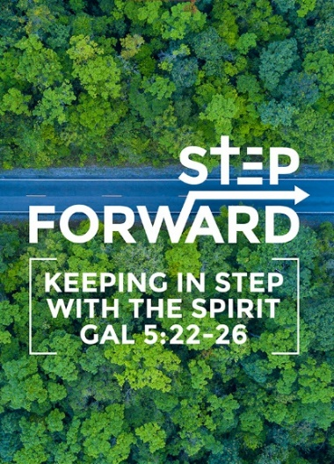
Credible Kingdom Hope: Prophetic Mission of the Church
(Habakkuk 2:2-4, 3:17-19)
By Dr Jayakumar Christian

Then the Lord replied, “Write down the revelation and make it plain on tablets so that a herald may run with it. For the revelation awaits an
appointed time; it speaks of the end and will not prove false. Though it linger, wait for it; it will certainly come and will not delay. 4See, the enemy is puffed up; his desires are not upright-but the righteous person will live by his faithfulness. (Habakkuk 2:2-4)

Though the fig tree does not bud and there are no grapes on the vines, though the olive crop fails and the fields produce no food, though there are no sheep in the pen and no cattle in the stalls, yet I will rejoice in the Lord, I will be joyful in God my Savior. The Sovereign Lord is my strength; he makes my feet like the feet of a deer, he enables me to tread on the heights. (Habakkuk 3:17-19)

Introduction
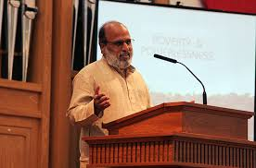
Dr. Jayakumar Christian is the National Director and CEO of World Vision India, with responsibility over almost 2,000 aid workers serving 2.4 million children in the country. He joined the organization in 1978, is an expert and author of numerous academic articles and books on poverty issues, the most recent of which is "God of the Empty Handed."

He requires that we be engaged from Monday to Saturday .This engagement comes withn the world demands and we are called us to be part of this Kingdom to operate between hope and hopelessness. How does DUMC operate between live and death? What does the Lord require?
BIG IDEA: Bringing Hope to the Hopeless – Be God’s Agent

What does the Lord require from you
Dr Jayakumar commented that worship is indeed a beautiful way to honour God but He requires more than that from us. He has a specific purpose for each one of us and wants our engagement with Him from the start. Our Mission is to bring Hope to the Hopeless in the world.
We need to remind the world about our God who brings Hope, against the wicked world. He can even use the ungodly to teach the Godly!

He commends DUMC for being so connected with the outside world especially when we pray for our neighbours during this fasting month of Ramadhan.

Being engaged does not come insulated from death and life; and we are called to be part of hope and hopelessness. Our mission is dealing with evil and wickedness and crying over our nation yet beware of becoming numb to evil which prevail around us all the time.

What is the Nature of the Agent of God for the Nation?
We are in a mission between hope and hopelessness. We are required to cry for our nation and are selected for a purpose. We are a minority and powerless in fate but just be dependent on God.
The heart of worship is God. We are deeply disturbed by all forms of evil in the world, yet we do missions in the context of wickedness and evil. Our mission is to remind the world that Our God has the final Word. How long shall I cry? (Hab.1:2) Only when our heart is broken, when we grief will we be in a prayer of submission to God. Prophetic grief precedes prophetic proclamation.

Mission is about dealing with wickedness and evil, not about increasing membership, it is about disturbing status quo, challenging wickedness and evil, learning to cry over our nation. Learning how to grief for our nation. Having an intense conversation about who we live and are surrounded with, resulting in submission to God’s Will. An intimacy which results in submission to God.

Key Themes for Constructing a Theology of Hope
Our God is deeply involved in the history of the nation; He warns that complacent attitude is sin – evil become normal.
At that time I will search Jerusalem with lamps and punish those who are complacent, who are like wine left on its dregs, who think, ’The Lord will do nothing, either good or bad.’ (Zephaniah1:12)

Our God is righteous & sovereign
His righteous intent and standards do not change. A witness to the reign of God. He is still on the throne. Our intimacy with God matters for the window of time is short for the healing of the nation.
The Lord is in his holy temple; let all the earth be silent before him.(Habakkuk2:20)

Our God may use various agents to fulfil His purposes
His purposes and righteousness never change; His sovereign decision. He uses the ungodly Babylonians (various agents) to teach the people of Judah. Agents do not become righteous because God uses them; righteous standards apply. The church must know how to collaborate with others in the world, be secure in our faith, not become arrogant or insecure but submit to the Spirit of the Lord. Our holiness must be contagious in the marketplace.
I am raising up the Babylonians, that ruthless and impetuous people, who sweep across the whole earth to seize dwellings not their own. (Habakkuk1:6)

The Just shall live by faith
We need to live by faith in spite of the lack of evidence. Let us pray for God to use us to invest in the transformation of our nation.
For the revelation awaits an appointed time; it speaks of the end and will not prove false. Though it linger, wait for it; it will certainly come and will not delay. (Habakkuk2:3)

Conclusion
- Is your heart deeply disturbed by the evil that is happening in the nation?
- Let us be aware of God’s righteousness and sovereignty.
- Let us build our intimacy with God and have our conversation with Him just like Habakkuk did through our personal prayer time with Him and prayer time as a body of the church.
- Let us live by faith even though we are restless as we wait upon the Lord and there is no evidence yet rejoice in the Lord who is our strength.

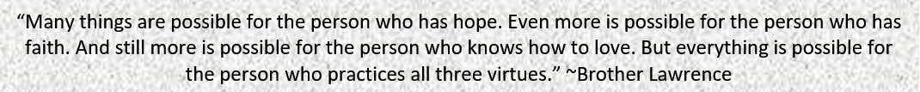

Sermon summary contributed by
Michelle Chuah

