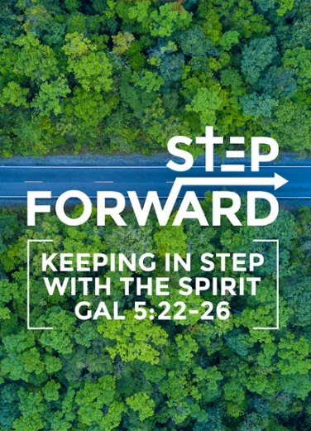
The Church & The Nation – Citizens & Nation Building:
Reflections from The Bible for Contemporary Action
Prof Datuk Dr Denison Jayasooria
(Joshua 24:11, Acts 16:37, Ephesians 2:19, Philippians 3:20)

Then you crossed the Jordan and came to Jericho. The citizens of Jericho fought against you, as did also the Amorites, Perizzites, Canaanites, Hittites, Girgashites, Hivites and Jebusites, but I gave them into your hands. (Joshua 24:11)

But Paul said to the officers: “They beat us publicly without a trial, even though we are Roman citizens, and threw us into prison. And now do they want to get rid of us quietly? No! Let them come themselves and escort us out.” (Acts 16:37)

Consequently, you are no longer foreigners and strangers, but fellow citizens with God’s people and also members of his household, (Ephesians 2:19)

But our citizenship is in heaven. And we eagerly await a Savior from there, the Lord Jesus Christ (Philippians 3:20)

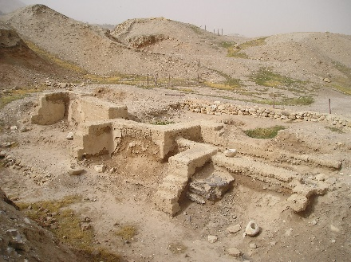
Citizen of Jericho
Then you crossed the Jordan and came to Jericho. The citizens of Jericho fought against you, as did also the Amorites, Perizzites, Canaanites, Hittites, Girgashites, Hivites and Jebusites, but I gave them into your hands. (Joshua 24:11)

Here the term ‘citizen’ is in reference to a person from that city or a people from a particular geographical location

Citizen of Rome (Acts 16:37; 22:25)
But Paul said to the officers: “They beat us publicly without a trial, even though we are Roman citizens, and threw us into prison. And now do they want to get rid of us quietly? No! Let them come themselves and escort us out.” (Acts 16:37)

As they stretched him out to flog him, Paul said to the centurion standing there, “Is it legal for you to flog a Roman citizen who hasn’t even been found guilty?” (Acts 22:25)

a. Roman Citizens
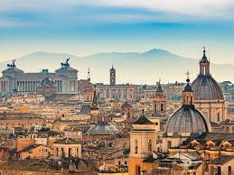
The Romans came after the Greeks. Being a Roman citizen has its privileged position & legal entity with rights. When Paul spoke this, most of the Jews were slaves and had to buy their citizenship. Paul was a tentmaker and church planter. Paul’s recognizes his privilege as a roman citizen.

Paul exercised his rights as a Roman. Among them were:

- Arrest only with charges.
Paul was beaten up like a slave. Arrest must be made only with charges.
- No abuse while in custody.
Sentencing only after trials are allowed. Paul was beaten for no reason.

- Access to fair trial.
Paul was exercising his rights as a roman citizen. He wanted justice to be served despite being asked to leave quietly.

In Malaysia, the concept of citizenship only came after 1957 after the Reeds Commission. We now live in a parliamentary democracy.

b. Biblical Principles of Citizenship:
During the biblical times people lived in theocracy, under God. Monarchy was an era where kings ruled. Democracy is the era we live in now with a few exceptions. There are principles of a Contemporary Citizenship. Malaysia is a constitutional Monarchy. The Sermon of the Mount and the Ten Commandments are universal. The current political & governance system is not directly mentioned in the Bible but there are principles.

- Stewardship (Gen 1:26).
Then God said, “Let us make mankind in our image, in our likeness, so that they may rule over the fish in the sea and the birds in the sky, over the livestock and all the wild animals,[a] and over all the creatures that move along the ground.” (Genesis 1:26)

The earth’s resources are handed over to humanity. God entrusts the whole of humanity in the hands of humans. Stewardship means it doesn’t belong to you. We cannot take our riches to the afterlife. The leader is responsible of his resources.

- Justice & fairness (Deuteronomy 1:17)
Do not show partiality in judging; hear both small and great alike. Do not be afraid of anyone, for judgment belongs to God. Bring me any case too hard for you, and I will hear it.” (Deuteronomy 1:17)

There should be no partiality. Justice and fairness should come from God.

- Honesty & good governance (Deuteronomy 1:12-13, 16:18-20)
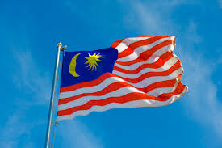
But how can I bear your problems and your burdens and your disputes all by myself? Choose some wise, understanding and respected men from each of your tribes, and I will set them over you.” (Deuteronomy 1:12-13)

Appoint judges and officials for each of your tribes in every town the Lord your God is giving you, and they shall judge the people fairly. 19 Do not pervert justice or show partiality. Do not accept a bribe, for a bribe blinds the eyes of the wise and twists the words of the innocent. 20 Follow justice and justice alone, so that you may live and possess the land the Lord your God is giving you. (Deuteronomy 16:18-20)

Leaders who lead should think of the nation and not set aside a portion for themselves or their family.
- Wealth creation (Deuteronomy 8:18)
But remember the Lord your God, for it is he who gives you the ability to produce wealth, and so confirms his covenant, which he swore to your ancestors, as it is today. (Deuteronomy 8:18)

We need to create wealth of some kind. God gives us resources to multiply.

- Wealth distribution (Deuteronomy 15:4)
There is enough in the world for everybody. There shouldn’t be any poor people in the world. This is God’s vision for the world. The leaders we choose need to have these principles.

c. Federal Constitution of Malaysia
Rights & Responsibilities as defined in the Federal Constitution. All politicians tell this but do not apply 100%. This was written by 5 people who were lawyers appointed by the British Government. Datuk Emeritus Professor Dr. Shad Saleem Faruqi mentioned that we do not practice Constitutional literacy. Dr. Dennison encouraged us to attend discussions on this. Paul knew his rights as a Roman citizen. Most of the time, the constitution is misinterpreted. There is a conflict between the might of the state and the right of the citizen. You have to pay direct and indirect taxes as a citizen. Constitutional literacy is lacking among the citizens.
Article 152 of the Federal Constitution states that the national language is the Malay language. In relation to other languages, the Constitution provides that:
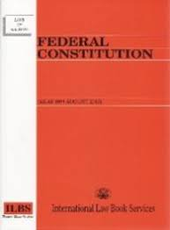
(a) Everyone is free to teach, learn or use any other languages, except for official purposes. Official purposes here mean any purpose of the Government, whether Federal or State, and includes any purpose of a public authority.
(b) The Federal and State Governments are free to preserve or sustain the use and study of the language of any other community.
Article 153 stipulates that the Yang di-Pertuan Agong, acting on Cabinet advice, has the responsibility for safeguarding the special position of Malays and the indigenous peoples of Sabah and Sarawak, and the legitimate interests of all other communities.

Article 4. (1) This Constitution is the supreme law of the Federation and any law passed after Merdeka Day which is inconsistent with this Constitution shall, to the extent of the inconsistency, be void. ... (b)if the law was made by the Legislature of a State, in proceedings between the Federation and that State.

The federal constitution moderates between the ‘might of the state’ & ‘rights of citizens’. Our shared destiny is to cultivate nation building in a divided society.

Fellow citizens of God’s People
Consequently, you are no longer foreigners and strangers, but fellow citizens with God’s people and also members of his household, (Ephesians 2:19)
In Christianity the concept of citizenship moves from a geographical location to citizens of God’s people. We belong to a new community of God’s people transcending religion race and colour. Fellowship of Love.

Citizens of Heaven
But our citizenship is in heaven. And we eagerly await a Savior from there, the Lord Jesus Christ (Philippians 3:20)

There is a heavenly dimension of our citizenship which is eternal. Why care of this world. Those who go to heaven they have their treasures on earth. We have to have faith to gain this passport to heaven.

After this I looked, and there before me was a great multitude that no one could count, from every nation, tribe, people and language, standing before the throne and before the Lamb. They were wearing white robes and were holding palm branches in their hands. (Revelation 3:20)

Revelation 3:20 shows the diversity of heaven.
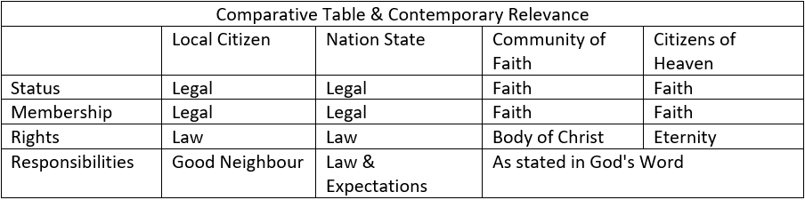

Conclusion:
A church member shared that when he had an accident, Malays helped. He was awarded this big contract where the ruling government did not ask him for a bribe. These incidents gave him a positive view of the government. We must make a stand to face the problems in our nation and not opt to move out or run away from the system.

Martin Luther King Jr. came from a good family of theologians. He learned from the Bible and Mahatma Gandhi’s of nonviolence movement. Drawing some lessons from Martin Luther King Jr (1929-1968) who exercised the rights of being an American citizen, and was motivated by the Love of Jesus in addressing racism and segregation. He used the segregation of Atlanta and started a nationwide movement that led to a nation that treated race equally.

You cannot use legalities as a national citizen to go to heaven. You need to be born again in Christ.
Pastor Chris ended by thanking the missionaries and labourers for coming from other countries and loving Malaysia as their own nation. Do not only pray for Malaysia but love Malaysia.

Sermon summary by: Abbey Thangiah

