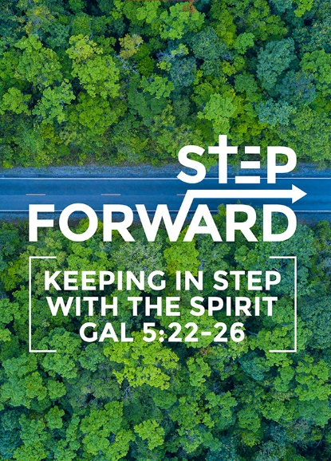
God Will Send Me
Senior Pastor Chris Kam

The Lord had said to Abram, “Go from your country, your people and your father’s household to the land I will show you. “I will make you into a great nation, and I will bless you; I will make your name great, and you will be a blessing. I will bless those who bless you, and whoever curses you I will curse; and all peoples on earth will be blessed through you.” So Abram went, as the Lord had told him; and Lot went with him. Abram was seventy-five years old when he set out from Harran. He took his wife Sarai, his nephew Lot, all the possessions they had accumulated and the people they had acquired in Harran, and they set out for the land of Canaan, and they arrived there. Abram traveled through the land as far as the site of the great tree of Moreh at Shechem. At that time the Canaanites were in the land. The Lord appeared to Abram and said, “To your offspring I will give this land.” So he built an altar there to the Lord, who had appeared to him. (Genesis 12:1-7)

Understand, then, that those who have faith are children of Abraham. Scripture foresaw that God would justify the Gentiles by faith, and announced the gospel in advance to Abraham: “All nations will be blessed through you.” So those who rely on faith are blessed along with Abraham, the man of faith. (Galatians 3:7-9)

Introduction
There is a movement that God is bringing in our lives as we reach DUMC’s 40th anniversary. IMPACT 2020 means we want to make an impact.

But the fruit of the Spirit is love, joy, peace, forbearance, kindness, goodness, faithfulness, gentleness and self-control. Against such things there is no law. Those who belong to Christ Jesus have crucified the flesh with its passions and desires. Since we live by the Spirit, let us keep in step with the Spirit. Let us not become conceited, provoking and envying each other. (Galatians 5:22-26)

We must never get ahead of God. We should let God be God and let Him lead you. Our part is to keep in step with Him. God will lead us to some interesting places and He will surprise you.

People tend to be uncomfortable when you announce something ahead of time. How many of us love changes in life? When we open our palms to God, He can give in an amazing way.

A good sermon comforts the disturbed and disturbs the comfortable.

Big Idea
Step Out of Your Comfort Zone

There are many stories of unexpected heroes in the Bible. For example, teenager Mary who was chosen to be the mother of Jesus, King David who is considered to be an ‘underdog’ as his father forgot about him, etc.

God choses many unknown people.
In Genesis 11, God has called Terah, the father of Abram, to leave Ur to go to Canaan. However, he ended up in Haran and did not go to Canaan. God then called Abram to go to Canaan.
God is sovereign and He has a plan.
The Lord had said to Abram, “Go from your country, your people and your father’s household to the land I will show you. “I will make you into a great nation, and I will bless you; I will make your name great, and you will be a blessing. I will bless those who bless you, and whoever curses you I will curse; and all peoples on earth will be blessed through you.” (Genesis 12:1-3)

In the above verse, there are four-fold blessings: that God will make Abram into a great nation, He will make Abram’s name great, He will bless those who bless Abram, and all peoples on earth will be blessed through Abram.

The Abrahamic Covenant has relevance to the church of today.

Three main features of the Abrahamic Covenant:
- The promise of the land. (Genesis 12:1)
- The promise of descendants. (Genesis 12:2)
- The promise of blessings and redemption. (Genesis 12:3)

“…and to make plain to everyone the administration of this mystery, which for ages past was kept hidden in God, who created all things. His intent was that now, through the church, the manifold wisdom of God should be made known to the rulers and authorities in the heavenly realms, according to his eternal purpose that he accomplished in Christ Jesus our Lord.” (Ephesians 3:9-11)

If the world needs to know about God’s plans for their lives, then it is through the church that this is done.

Understand, then, that those who have faith are children of Abraham. Scripture foresaw that God would justify the Gentiles by faith, and announced the gospel in advance to Abraham: “All nations will be blessed through you.” So those who rely on faith are blessed along with Abraham, the man of faith. (Galatians 3:7-9)

We are called children of Abraham. All nations will be blessed through you. The role of the church is to bring the gospel to the world.

Hear
Think of something you have never tried.
For Abram to step out, he needed to hear first. Listen to God about what He’s saying about your life. Most important is to hear from God. Have a dream so big that unless God is in them, you are bound to fail. However, nothing will happen if you do not go. Abram, at 75 years old, went as he obeyed God.

What excuses do you give? Too young? Too old? Not capable? We all give all kinds of excuses.

So Abram went, as the Lord had told him; and Lot went with him. Abram was seventy-five years old when he set out from Harran. He took his wife Sarai, his nephew Lot, all the possessions they had accumulated and the people they had acquired in Harran, and they set out for the land of Canaan, and they arrived there. (Genesis 12:4-5)

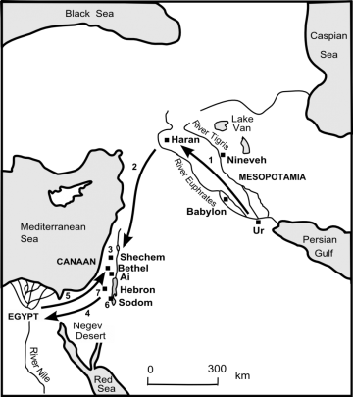
Obey
Do something you have never done.
The distance from Ur to Haran is approximately 900km, and Haran to Shechem is another 800km approximately. Travelling between such places is no easy feat in those days.

We need a measure of listening in order to obey.

Go
Go somewhere you have never been.
Abraham obeyed even though he did not know where he was going.

By faith Abraham, when called to go to a place he would later receive as his inheritance, obeyed and went, even though he did not know where he was going. (Hebrews 11:8)

What does IMPACT2020 mean?
- In our personal life
- In our work life
- In our ministry
- Wherever God has placed us

Scope
- Everyone can do
- Most can do
- Only a few can do

Abram traveled through the land as far as the site of the great tree of Moreh at Shechem. At that time the Canaanites were in the land. The Lord appeared to Abram and said, “To your offspring I will give this land.” So he built an altar there to the Lord, who had appeared to him. (Genesis 12:6-7)

Senior Pastor Chris Kam invited three individuals to share their respective testimonies.

Testimony 1 - Jackie (via a recording)
Jackie attends DUMC Puchong and accepted Christ in February 2019. She runs a shop named Terrymart. She shared that teaching is always something that is close to her heart, and something that the Lord has called her to do even though she does not feel too confident about it. Eventually, she engaged help and partitioned her shop to make space for special needs children, as she feels that special needs children need to be given an opportunity to have their business too. Jackie shared that mothers need to know that there is hope for their children.

Testimony 2 – Jerry Teo
Jerry serves at Community Excel Services’ Street Ministry for over 13 years. He started serving even though his life was a mess at that time. However, his heart changed as he continued serving. In his ministry, he reaches out to the homeless, hungry and needy. One of the many people that he met in the Street Ministry is a man named Ah Long, who has been kicked out by his family. Being in the Street Ministry has allowed Jerry to assist in meeting Ah Long’s basic needs. Jerry also shared about Uncle Lim, who had been living in the streets for many years, as he was lost in dealing with grief. He is also afraid of being bullied by workers in homes. Later, he found a job as a chef to cook at a children’s home. Jerry is glad that Uncle Lim found hope and purpose to live in the later years of Uncle Lim’s life.
Testimony 3 – Dr Lim Kah Hooi
Kah Hooi runs an entrepreneur school. He started a Christian business school in 2017, called The Encubator, after realising that there is no Christian business school in Malaysia. This allows him to bring a community of Christians together, even though they were struggling with the idea of starting something new. This Christian business school has produced three batches of students already, with 40 people being in the CEO roundtable. Kah Hooi highlighted four notable students in the course of running the business school: (1) a non-believer student gave her life to Jesus on the 3rd day of the course as she has observed that the Christian way of doing things are different; (2) Noah Lim, a 4-month old Christian, has developed an automated noodle factory; (3) Pang Sze Chong, who founded a mobile experience store called Big Fat Smile; and (4) Chu Ee Vynn, who founded The Treehouse, a kindergarten based on Christian principles tailored after one of the best kindergarten curriculum, and is the only kindergarten in Malaysia to be given permission to use such curriculum because of its Christian principles; two of its teachers have given their lives to the Lord already.

Our dreams are not big because God is not in the picture.

When Jesus looked up and saw a great crowd coming toward him, he said to Philip, “Where shall we buy bread for these people to eat?” He asked this only to test him, for he already had in mind what he was going to do. Philip answered him, “It would take more than half a year’s wages[a] to buy enough bread for each one to have a bite!” Another of his disciples, Andrew, Simon Peter’s brother, spoke up, “Here is a boy with five small barley loaves and two small fish, but how far will they go among so many?” Jesus said, “Have the people sit down.” There was plenty of grass in that place, and they sat down (about five thousand men were there). Jesus then took the loaves, gave thanks, and distributed to those who were seated as much as they wanted. He did the same with the fish. When they had all had enough to eat, he said to his disciples, “Gather the pieces that are left over. Let nothing be wasted.” So they gathered them and filled twelve baskets with the pieces of the five barley loaves left over by those who had eaten. (John 6:5-13)

The boy with the five loaves and two fishes came with an open palm with all that he had, and Jesus multiplied it with 12 basket-ful of leftovers. God will take what you have and multiply it.

“Never worry about numbers. Help one person at a time and always start with the person nearest you.” ~Mother Teresa

Sermon summary contributed by May

