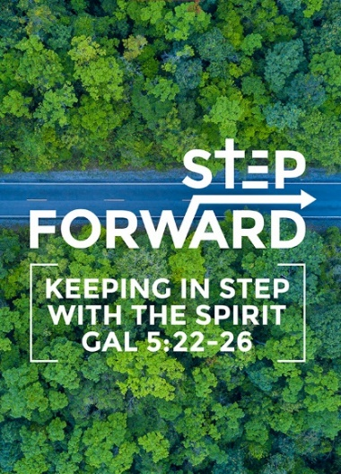
Storms, Shipwrecks and Snakebites
(Acts 27: 18 - 26)
Reverend Phillip Deas
The next day, as gale-force winds continued to batter the ship, the crew began to throw the cargo overboard. The following day they even took some of the ship’s gear and threw it overboard. The terrible storm raged for many days, blotting out the sun and the stars, until at last all hope was gone. No one had eaten for a long time. Finally, Paul called the crew together and said, “Men, you should have listened to me in the first place and not left Crete. You would have avoided this damage and loss. But take courage! None of you will lose your lives, even though the ship will go down. For last night an angel of the God to whom I belong and whom I serve, stood beside me, and he said,’ Don’t be afraid, Paul, for you will surely stand trial before Caesar! What’s more, God in his goodness has granted safety to everyone sailing with you. So take courage! For I believe God. It will be just as he said. But we will be shipwrecked on an island.’
BIG IDEA
Take a step of faith and make an impact. In this world we will have trouble, opposition but …. we focus on God! We stand on the
promises of God.

Introduction
Paul was going in the right direction. Nobody prays for storms, shipwrecks, and snake bites. But they will come.

“I have told you these things, so that in me you may have peace. In this world you will have trouble. But take heart! I have overcome the world.” (John 16:33)

Jesus told us as long as we are on earth, we will face troubles. We will face challenges.

You cannot ever allow your outlook on life to be determined by your opposition in life. Your outlook must be determined by what is in you, not what is around you.

Consider David when he was facing Goliath. For 40 days, Goliath mocked God and threatened the Israelite soldiers. The soldiers were preparing to retreat as they only saw the size of the enemy. David on the other hand looked at God. The giant did not have a chance.

because the one who is in you is greater than the one who is in the world. (1 john 4:4)

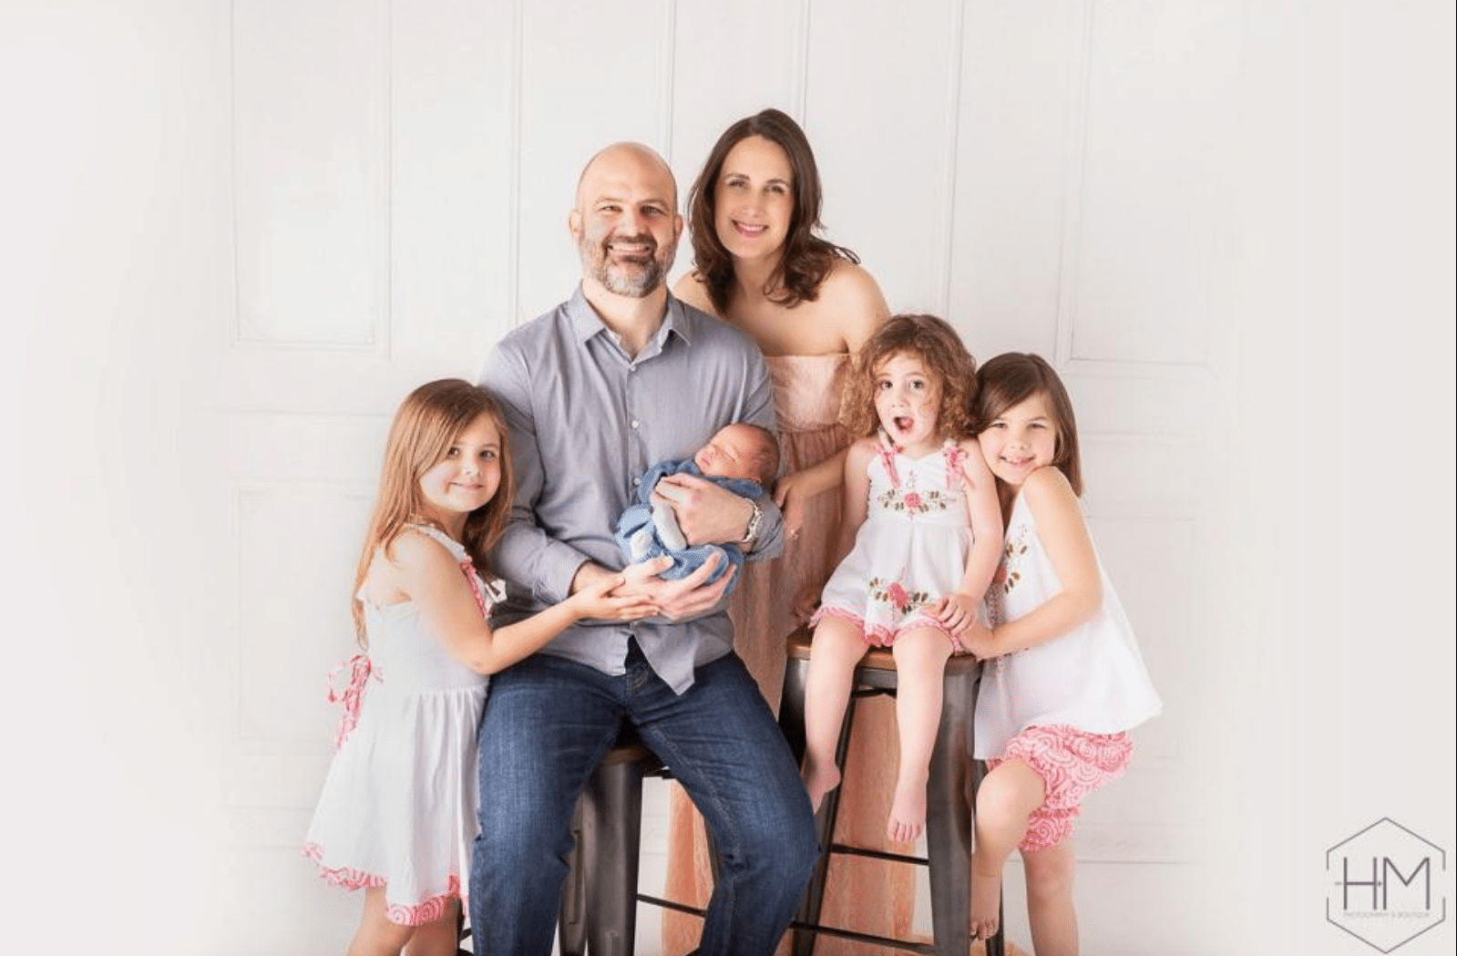
At age eighteen, Phillip Deas had an encounter with God that created a desire to live a life completely sold out to the purpose of God. This experience sparked a passion inside of him to see others reach their God given potential. Phillip's greatest joy is seeing people’s lives transformed by the truth of God’s Word and then watching them impact their world. Married to a lawyer, Destiny Duron and has 4 children. He is the lead pastor in Northpoint Community Church, Louisiana, US.

As we prepare to equip ourselves for IMPACT 2020, we need to ready to get out of our comfort zone. We have to be comfortable being uncomfortable. We need to step out in faith. There will be opposition, we need to keep our eyes on the author and finisher of our faith.

Reverend Phillip Deas says that there are 3 lessons to learn from the Paul’s trouble, storm, shipwreck and snake bites!

When in a Storm, STAND

The ship was in the storm. They did not know where they were, and they did not know where they were going. A lot of unknown can create much fear.

Let us not focus on the storm in our lives as we could not see what is going to happen next. We have to STAND on God’s promises, His Word and believe God. We have courage when we trust and choose to believe God in the Lord and be driven by faith.

Peace comes when we choose to stand on the promises of God. The storm is not in control of our future unless we give it control. The storm could delay us, it could disrupt us but it cannot destroy us. We choose “it will be just as He said” or “it will be just as we fear”. We are either driven by faith or driven by fear. All things are possible through Christ who gives us strength.

… he will never leave you nor forsake you. (Deuteronomy 31:6)
no weapon forged against you will prevail … (Isaiah 54:17
… I can do all things through Christ who strengthens me. (Philippians 4:13)

When in a Shipwreck, SWIM
Then he ordered all who could swim to jump overboard first and make for land. The others held on to planks or debris from the broken ship. So everyone escape safely to shore.

If a storm is what could happen, a shipwreck is what do I do now? What do we do when things in life begin to fall apart? We swim in the shipwreck! We swim because we refuse to sink in despair. We swim because we believe the best is yet to come. We swim to get to the shore. We believe that as long as we are still breathing then God is not done with us.

What happens when we hear the news we never thing we would hear? What do you do when you are hurting so bad? What do you do when life gives you a punch and takes your breath away? Swim. And if we cannot swim, grab on something. Some of us are floating in waters. Some of us have gone through tough times. They could help those floating to get to the shore. They do not need help all the time, just enough to get to the shore.

Seeking help is not a sign of weakness. It is a sign of wisdom.

When you are in your shipwreck, during trials and tribulations which takes your strength or breath away, you need to reach out to those who had overcome to stand with you. God will place people who can help us when we need one another.

When bitten by the Snake, SHAKE
As Paul gathered an armful of sticks and was laying them on the fire, a poisonous snake, driven out by the heat, bit him on the hand. But Paul shook off the snake into the fire and was unharmed. (Acts 28:3,5)
When we are trying to do His Will, the enemy will come to accuse and strike at our past sins to distract us of our potential future, to get us to look backwards than look forward to our better future.

The snake was hanging to Paul’s hand like an accusation. Paul was a murderer. He persecuted God’s followers.

The enemy accuses us of our sinful past so we can be excused form the potential future. The enemy is afraid of a church that stops looking over the shoulder and instead focus on the future. The enemy wants us to put our attention to the past and forget about moving forward.

God wants to talk to us about our future. He wants to talk to us about what we can do. So, we shake the snake (the accusation) into the fire.

Sometimes we live with the snake so long it becomes our pet. We go to church but we still live in sin and condemnation. We need to shake it off. The might be what happened in the past. But we are no longer the same person. We want to look forward to what we can do in the future.

… But one thing I do: Forgetting what is behind and straining toward what is ahead. (Philippians 3:13b)

Therefore, as we have opportunity, let us do good to all people, especially to those who belong to the family of believers. (Galatians 6:10)

We shake off the snake that bites into the ‘fire’ of God and be set free to answer God’s call for the future which God has for you. Breakthroughs and miracles happen after the storm, shipwreck or snake bite.

Conclusion
In God’s presence,
- we can STAND in the midst of the storm.
- we still SWIM even in the midst of a shipwreck.
- we must SHAKE the snake into God’s fire when it bites.
So let us not get tired of doing good. At the right time we will reap a harvest of blessing if we do not give up. Therefore , whenever we have the opportunity, we should do good to everyone – especially to those in the family of faith. (Galatians 6:9-10 NLT)

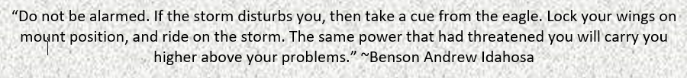

Sermon summary by Michelle Chuah

