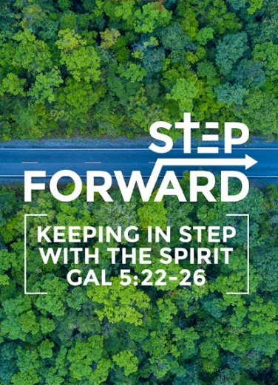
Step Forward in Faith (1 Samuel 17:45 - 51)
Pastor Chris Manivannan

David said to the Philistine, “You come against me with sword and spear and javelin, but I come against you in the name of the Lord Almighty, the God of the armies of Israel, whom you have defied. This day the Lord will deliver you into my hands, and I’ll strike you down and cut off your head. This very day I will give the carcasses of the Philistine army to the birds and the wild animals, and the whole world will know that there is a God in Israel. All those gathered here will know that it is not by sword or spear that the Lord saves; for the battle is the Lord’s, and he will give all of you into our hands.”
As the Philistine moved closer to attack him, David ran quickly toward the battle line to meet him. Reaching into his bag and taking out a stone, he slung it and struck the Philistine on the forehead. The stone sank into his forehead, and he fell facedown on the ground.
So David triumphed over the Philistine with a sling and a stone; without a sword in his hand he struck down the Philistine and killed him.
David ran and stood over him. He took hold of the Philistine’s sword and drew it from the sheath. After he killed him, he cut off his head with the sword. (1 Samuel 17:45-51)
BIG IDEA:
There is YOU WANT VICTORY? BE OBEDIENT!

Introduction
We are all faced with Giants in our lives. It is how we respond to them. Do we fight or do we run? It is all a matter of perspective.
Mount Everest is the world's highest mountain at 8,848 m, in comparison, Mt Kinabalu Malaysia’s highest mountain is 4,095 m. Mt Kinabalu may be the highest in Malaysia, but it is not even half the height of Mt Everest.

Whatever you are facing, you must have the right perspective.

Obedience leads to supernatural victory. God’s divine appointment places us at the right place and at the right time to bring honour to His Name.
In 1 Samuel 17:20, David was obedient to his father and went to bring food to his brothers in the battlefield. This gave him the opportunity to become a national hero. He was at the right place at the right time and brought glory to God.

Definition of Faith:
Now faith is the substance of things hoped for, the evidence of things not seen (Hebrews 11:1) (NKJV)

a. Faith is the substance (or title deed) of things not seen.
b. Faith means that we are convinced of what we do not see.
c. Faith is to believe you have received even before you actually receive.

THE 3 (THREE) C’s OF FAITH:

The Cause (Objective) of Faith (1 Samuel 17:23-30)
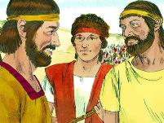
As he was talking with them, Goliath, the Philistine champion from Gath, stepped out from his lines and shouted his usual defiance, and David heard it. Whenever the Israelites saw the man, they all fled from him in great fear. Now the Israelites had been saying, “Do you see how this man keeps coming out? He comes out to defy Israel. The king will give great wealth to the man who kills him. He will also give him his daughter in marriage and will exempt his family from taxes in Israel.” David asked the men standing near him, “What will be done for the man who kills this Philistine and removes this disgrace from Israel? Who is this uncircumcised Philistine that he should defy the armies of the living God?” They repeated to him what they had been saying and told him, “This is what will be done for the man who kills him.” When Eliab, David’s oldest brother, heard him speaking with the men, he burned with anger at him and asked, “Why have you come down here? And with whom did you leave those few sheep in the wilderness? I know how conceited you are and how wicked your heart is; you came down only to watch the battle.” “Now what have I done?” said David. “Can’t I even speak?” He then turned away to someone else and brought up the same matter, and the men answered him as before. (1 Samuel 17:23-30)

- God’s call depends on two things: (1) the Word of God, and (2) the opportunity at hand.
- There will be opposition when you set out to do something for God.

- Eliab denounced David (1 Samuel 17:28)
His own brother looked down on hi. David’s response in verse 29 was,
“Now what have I done?” said David. “Can’t I even speak?”
Be patient, there is no need to defend and argue as long as you are called and obedient.

- Saul discouraged David (1 Samuel 17:.33)
It was Saul’s responsibility to fight with Goliath. He discouraged David but could not stop him.

- Goliath despised David (1 Samuel 17:.42)
David was a still a boy and not a warrior. Goliath despised him as this was a fight of all fights and here was a boy coming out to meet him.

The Confidence of Faith (1 Samuel 17: 31-47)
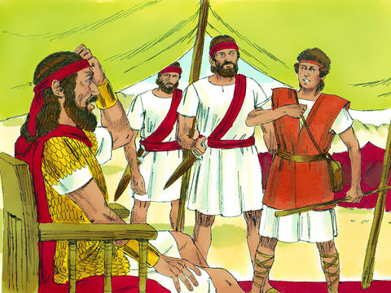
What David said was overheard and reported to Saul, and Saul sent for him. David said to Saul, “Let no one lose heart on account of this Philistine; your servant will go and fight him.”
Saul replied, “You are not able to go out against this Philistine and fight him; you are only a young man, and he has been a warrior from his youth.” But David said to Saul, “Your servant has been keeping his father’s sheep. When a lion or a bear came and carried off a sheep from the flock, I went after it, struck it and rescued the sheep from its mouth. When it turned on me, I seized it by its hair, struck it and killed it. Your servant has killed both the lion and the bear; this uncircumcised Philistine will be like one of them, because he has defied the armies of the living God. The Lord who rescued me from the paw of the lion and the paw of the bear will rescue me from the hand of this Philistine.”
Saul said to David, “Go, and the Lord be with you.”
Then Saul dressed David in his own tunic. He put a coat of armor on him and a bronze helmet on his head. David fastened on his sword over the tunic and tried walking around, because he was not used to them.
“I cannot go in these,” he said to Saul, “because I am not used to them.” So he took them off. Then he took his staff in his hand, chose five smooth stones from the stream, put them in the pouch of his shepherd’s bag and, with his sling in his hand, approached the Philistine.
Meanwhile, the Philistine, with his shield bearer in front of him, kept coming closer to David. He looked David over and saw that he was little more than a boy, glowing with health and handsome, and he despised him. He said to David, “Am I a dog, that you come at me with sticks?” And the Philistine cursed David by his gods. “Come here,” he said, “and I’ll give your flesh to the birds and the wild animals!”
David said to the Philistine, “You come against me with sword and spear and javelin, but I come against you in the name of the Lord Almighty, the God of the armies of Israel, whom you have defied. This day the Lord will deliver you into my hands, and I’ll strike you down and cut off your head. This very day I will give the carcasses of the Philistine army to the birds and the wild animals, and the whole world will know that there is a God in Israel. All those gathered here will know that it is not by sword or spear that the Lord saves; for the battle is the Lord’s, and he will give all of you into our hands.” (1 Samuel 17:31-47)

- Confidence of Past Successes (1 Samuel 17:34, 35)
David was confident as he had fought and killed the lion and the bear while protecting the sheep. The little battles in life prepares you for bigger battles ahead. We move step-by-step to bigger things in our lives.

- Confidence of Proven Strategies (1 Samuel 17:39-40)
David learned from his experiences killing the lion and the bear. He knew he had to keep his distance from Goliath.

- Confidence to Promptly Strike (1 Samuel 17:40b)
He was confident that he had to be quick and make the first move. It was a faith in the living God.

The Conquest of Faith (1 Samuel 17:48-51)
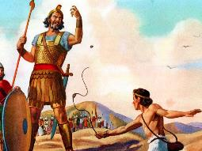
As the Philistine moved closer to attack him, David ran quickly toward the battle line to meet him. Reaching into his bag and taking out a stone, he slung it and struck the Philistine on the forehead. The stone sank into his forehead, and he fell facedown on the ground. So David triumphed over the Philistine with a sling and a stone; without a sword in his hand he struck down the Philistine and killed him. David ran and stood over him. He took hold of the Philistine’s sword and drew it from the sheath. After he killed him, he cut off his head with the sword. When the Philistines saw that their hero was dead, they turned and ran. (1 Samuel 17: 48-51)
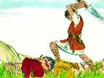
Faith does not wait for victory – it anticipates Victory!

How could one stone bring down Goliath? We cannot comprehend this. It is faith that our God will help us in our battles. David went to the battle with only his staff and sling. He used Goliath’s own sword to cut Goliath’s head. We see this happening over and over again. The weapons the enemy has for our destruction is used against them.
We can see this in Esther 7:10
So they hanged Haman on the gallows that he had prepared for Mordecai. Then the wrath of the king abated. (ESV)

Conclusion

1. The Cause (Objective) of Faith
2. The Confidence of Faith
3. The Conquest of Faith

Fast-forward 1,000 years after David’s victory, we see Jesus in the garden of Gethsemane. He knew the plan of the Father was for Him to suffer and die. It would be difficult, and He did not want to go through it, yet He was obedient to the Father. In the end, Jesus became the Saviour of the world.

Do not despise small and humble beginnings.
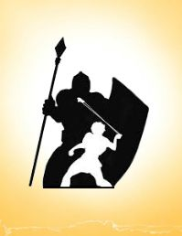
- David a forgotten shepherd boy was obedient to his father and became a national hero.
- Jesus a carpenter’s son was also obedient to His Heavenly Father and He back the Saviour of the world.

No matter how BIG a Giant you face, GOD is BIGGER

God is our Commander. With Him we can overcome and succeed.

God is challenging us to STEP FORWARD IN FAITH AND SEE A VICTORY!
“Obedience is the only reality. It is faith visible, faith acting, and faith manifest. It is the test of real discipleship among the Lord's people.” ~J.C. Ryle
Sermon summary by: Prudence Tay

