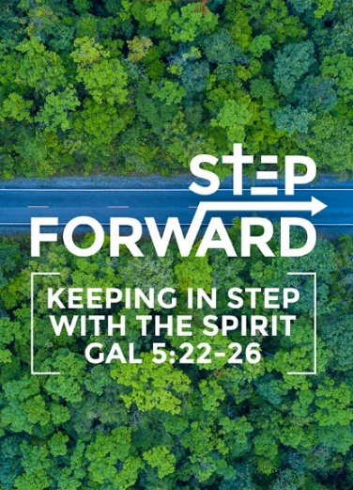
The Mission Heart of God: For the People Here
Pastor Datuk Kee Sue Sing
(Matthew 9:35-38; Acts 1:8)

Jesus went through all the towns and villages, teaching in their synagogues, proclaiming the good news of the kingdom and healing every disease and sickness. When he saw the crowds, he had compassion on them, because they were harassed and helpless, like sheep without a shepherd. Then he said to his disciples, “The harvest is plentiful but the workers are few. Ask the Lord of the harvest, therefore, to send out workers into his harvest field.” (Matthew 9:35-38)

But you will receive power when the Holy Spirit comes on you; and you will be my witnesses in Jerusalem, and in all Judea and Samaria, and to the ends of the earth.” (Acts 1:8)

Introduction

Two things come to mind when we think of missions.
- It is over there and far, far away. We support them and pray for them when they are down with weird diseases.
- Over there, they need Christ more than us over here. It is more Christ over here. The fact is, we need Christ here as much as there.
Our course of action needs to be local.

The Big Idea:
Our mission field is over there, right here, and everywhere. Get busy!

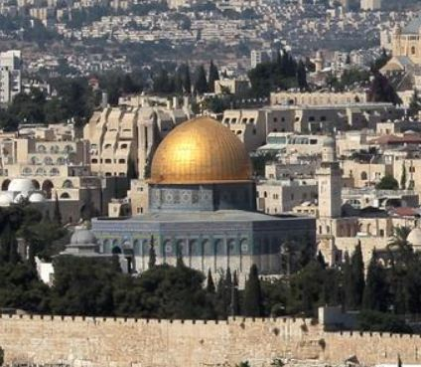
The Mission Fields (Acts 1:8):
But you will receive power when the Holy Spirit comes on you; and you will be my witnesses in Jerusalem, and in all Judea and Samaria, and to the ends of the earth.” (Acts 1:8)

You will be my witnesses in:
(1) your own area;
(2) your region among those of other cultures; and
(3) all over the world.

What is your “Jerusalem”?
All those who are around us. There are also many people where God has sent them to our doorsteps where missionaries are forbidden to enter. Knowing our Jerusalem is not good enough. Letting them know Jesus is more urgent. Even Jesus reached to the harvest. Jesus talked about a crop that will be lost when it is not picked when ripe. The farmer rushes the workers to harvest quickly rather than complaining and relaxing in the fields. Jesus is talking about the souls of the people who are unreached.

What are we doing? What practical actions can we take as a local church? Where do we start?

Be concerned

The eyes to see.

Jesus went through all the towns and villages, teaching in their synagogues, proclaiming the good news of the kingdom and healing every disease and sickness. When he saw the crowds, he had compassion on them, because they were harassed and helpless, like sheep without a shepherd. (Matt 9: 35,36)

“saw” = to know

Jesus did not look at people at a superficial level. He looked beyond the soul of the people. We get a picture of people with desperate needs, helpless and hopeless in their current situation. They have no help. Jesus saw and was concerned. How do we see? Do we even see? We exist in a comfortable neighbourhood for too long that we become oblivious to what is going on that we do not see anymore. We confine ourselves to the walls of our church week after week in our CAVE mentality. We need to see them differently today.

Look at our own surroundings. Look at google map and map out our surroundings and identify others. Pastor Kee and a few others mapped out Damansara Utama. They walked two by two and prayed for the community. There were about 30 pubs in Uptown. Nowadays there are 10.

When we pray, we reclaim the strongholds of Satan and all along the way, they asked the Holy Spirit to help them see the condition of the people in our Jerusalem. There are debts and sicknesses even in Christian homes. People are engaging in sex as young as 11 or 12 years old. Workers are being exploited. It looks so overwhelming that we do not do anything.

Pastor Kee shared that an old lady that has been worshipping idols he whole life and accepted Christ immediately. She requested that all the idols be removed and the team had to call a 3-tonne truck to remove all the idols. The more we see the more we will break our heart of our brokenness.

What do we do when we see?

“…… they were harassed and helpless, like sheep without a shepherd.” (Mt. 9:36b)

The Heart to Feel (Matthew 9:36)

“When he saw the crowds, he had compassion on them, because they were harassed and helpless, like sheep without a shepherd.” (Mt. 9:36)

Jesus always had compassion for the people. He felt their pain and rejection. He felt their sorrow and mourn for them. He never judged the adulteress.

“compassion” = stirred at the deepest level

Peter and John literally passed the man countless times for prayer. After Pentecost, they looked at him as the way Jesus sees. That look is history and is listed in the bible. We need to see people who we are interacting with as the way Christ has died for them. It began when Peter looked with compassion.

“Peter directed his gaze at him.” (Acts 3:4 ESV)
And Peter directed his gaze at him, as did John, and said, “Look at us.” (Acts 3:4 ESV)

“gaze” = seeing in a first time

There was a lot of plotting and scheming taking place. Pastor shared in the SIB Men’s Fellowship. We were once hurt and always continue to be hurt by family. It is how we respond to the situation that matters.

The hands to grind (Acts 4: 34 -35)
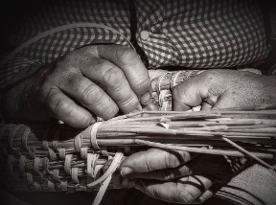
One We have heard “if we fail to plan we plan to fail”, the more truthful saying is “to fail to act is an act of failure”

Earn their right

We must earn the right to show God’s love to them

“There were no needy persons among them. For from time to time those who owned lands or houses sold them, brought the money from the sales and put it at the apostles’ feet, and it was distributed to anyone as he has need.” (Acts 4:34-35)

Jerusalem was able to grow rapidly because the good news of Christ created good works, good soil and good response. When we do something for someone else, they are more inclined to listen to you and hear you out. Be very careful in our self-righteousness.

Unless we confess the truth and hatred to God, we are like hypocrites. Our “Jerusalem” changes when we change first.

Stop Prejudice
We need to reach to people we like and do not like as well. There are people in our circles we do not like (for example, race). We perceive many bad things about them. We accuse foreigners to take our income and space.

Be Counted

Then he said to his disciples,

“The harvest is plentiful …” (Matthew 9:37a)

“I tell you, open your eyes and look at the fields! They are ripe for harvest.” (Jn. 4:35)

The problem: Labourers.

The task of mission is urgent but who will do the work? Will we do the work? In Mark, Jesus cast the devil to 2000 pigs. Pig owners asked Jesus to leave the town. The man who was delivered wanted to follow him but Jesus said no. Jesus did not deliver him to be comfortable but to go and share and make a difference in his community. It is strange Jesus will answer the pig owner’s prayer but not the one who wanted to follow him. We can be put back right where we are and making a difference.

The Locard’s Exchange Principle: Every contact leaves a trace.

As a forensic scientist, many cases have been solved by this alone. When Pr. Daniel preached about Joseph, we can see that wherever Joseph was, he left a blessing at every stage in his life. Is cell a better place because you are there? Your college? Neighbourhood? Every contact leaves a trace.

Be Caught Up

“Ask the Lord of the Harvest, therefore, to send out workers into his harvest field.” (Mt. 9:38)

“Ask” simply means pray.

The Lord’s Prayer is a daily reordering of our priorities.

- Hallowed be Your name = Let Your name and fame be known, revered, and loved.
- Thy Kingdom come = Let Your agenda and priorities be mine as well.
- Thy will be done = Let the parts I do not like be my act of worship and surrender.
- “Amen” = Begin to care about what He does.

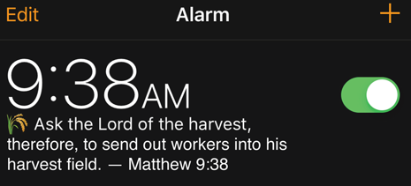
We will see our life the way Jesus did by praying this prayer.

Ask the Lord of the harvest, therefore, to send out workers into his harvest field.” (Matthew 9:38)

Say a silent prayer at this time. When we pray, God will tap you and ask, “What about you?”

Conclusion
Start where you are at, then love on it. See them won for Christ.

Many of us who have received Jesus are no doing enough. Start today.

Sermon summary by: Abbey Thangiah

