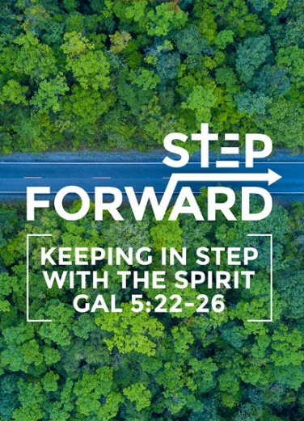
Stand on The Hill
(Exodus 4:2, 17:8-13)
Dato’ Dennis Ignatius

Then the Lord said to him, “What is that in your hand?” “A staff,” he replied. (Exodus 4:2)

The Amalekites came and attacked the Israelites at Rephidim. Moses said to Joshua, “Choose some of our men and go out to fight the Amalekites. Tomorrow I will stand on top of the hill with the staff of God in my hands.” So Joshua fought the Amalekites as Moses had ordered, and Moses, Aaron and Hur went to the top of the hill. As long as Moses held up his hands, the Israelites were winning, but whenever he lowered his hands, the Amalekites were winning. When Moses’ hands grew tired, they took a stone and put it under him and he sat on it. Aaron and Hur held his hands up—one on one side, one on the other—so that his hands remained steady till sunset. So Joshua overcame the Amalekite army with the sword. (Exodus 17:8-13)

Introduction
In the context of this passage, the Israelites were out of Egypt, roaming in the desert for about two months, but they have not reached their Promised Land. They were in a difficult place of having had to leave their comfort zone and to go to a place of which they have not yet reached. Also, they were in the land of the Amalekites, who were their enemies. Besides that, they ran out of water while in the desert, and they run the risk of the Amalekites attacking them. They were filled with fear, and begin to ask, “Is the Lord among us?”

Many times, we know that something better is coming, but because of the difficulties we face, we might start to wonder if we should settle for something that is less than God’s best. The Bible repeatedly tells us to remember what God has in store for us, through us and in us. When we go through those times of difficulty, God wants us to remember. The Israelites had forgotten and started to murmur. However, in the midst of the murmuring, one man stood up and said, “I will go and stand on the hill.” When that man raised his staff up, the Amalekites were defeated.
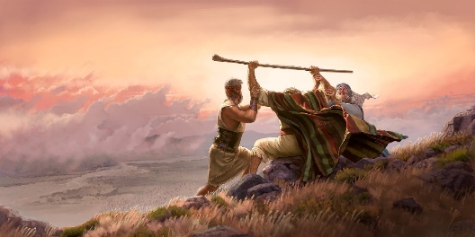
BIG IDEA
The Man, The Staff and The Hill

The Man

BIG IDEA # 1
It is not about who you are but about who God is!

“So now, go. I am sending you to Pharaoh to bring my people the Israelites out of Egypt.” (Exodus 3:10)

God always starts with a man. God has a purpose and a plan that was unfolding, and He looked for a man or a woman to carry out that plan. He can do it Himself but He wants to partner with us.

God is not looking for a perfect man or woman. All the people He called ran away, for they all felt inadequate. They were all not ready.

- Who am I that I should go to Pharaoh?
- What if they do not believe me or listen to me?
- I have never been eloquent… I am slow of speech and tongue.
- I speak with faltering lips; why would Pharaoh listen to me?
- Please send someone else.

God knows everything about us, He knows our faults and failures and secret sins. However, it is not about who you are, it is about who God is. Whenever we give excuses, God’s reply is always the same, “I will be with you.”, and “My grace is sufficient for you, for my power is made perfect in weakness.” Our faults and failures do not matter anymore, for what matters is God’s power and God’s ability.

Mother Teresa has a sign on a wall in her house that says, “God did not call me to be successful, He called me to be faithful.”

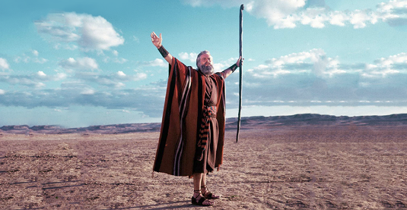
The Staff

BIG IDEA # 2
God has put seeds of greatness within you.

Then the Lord said to him, “What is that in your hand?” “A staff,” he replied. (Exodus 4:2)

For this reason I remind you to fan into flame the gift of God, which is in you through the laying on of my hands. (2 Timothy 1:6)

God equips all that He calls.

God had said that He will use Moses’ staff as a symbol of authority and power. Ever since then, the staff of Moses became the staff of God. The power that empowers the staff is from God, not from us. Each of us has a staff, and the staff represents God’s gifts and talents which He has given us. When God says something in His Word about us, we are to claim it.

God has put the seeds of greatness in each one of us. Since we were young, He has been preparing us, shaping us for His good works. The staff we have been given is fashioned from the Word of God.

- If you have faith… nothing shall be impossible to you (Matthew 17:20)
- Signs shall follow them that believe (Mark 16:17)
- Authority over all the power of the enemy (Luke 10:19)
- I have given them the glory that you gave me (John 17:22)
- You shall receive power when the Holy Spirit comes upon you (Acts 1:8)
- You are more than a conqueror (Romans 8:37)
- Every promise is yes and amen in Christ (2 Corinthians 1:20)

There is no such thing as an ordinary Christian. How can we be ordinary after what God has done in and through us? An ordinary Christian is a Christian that has not yet discovered their staff. Moses keeps leaving his staff behind, and God had to keep telling him to take the staff along with him. He was meant to carry it around with him and let it become a part of him.
When Moses panicked in difficult situations, and he came crying to God, God told him to use his staff. Do not expect God to do what God expects you to do. God has already given us our staff, we are to use it.
Fan the flames, use the gifts. As you go, the anointing will grow.

“If something is worth doing, it is worth doing poorly until you can do it well.” – G. K. Chesterton.

The Hill

BIG IDEA # 3
God did not call you to sit in church but to stand on the hill.

From Horeb to Rephidim.

We do not remain where we are, we move from the place of encounter to the place of service. God takes us on this journey. He does not leave us in the place of encounter, He takes us to the place of service. He puts us in situations to stretch us and to position us for what He has for us to do. We will not be the same, we will grow.

We are all called to be ministers unto the Lord, we are all called servants of God, ambassadors for Christ. There is a saying that goes, “If you believe in something, preach it, practice it, live it”. Or else you are a fake. You will never reach your full potential in Christ if you do not stand on the hill. What do you do if you pray for someone and they do not get healed? You move on to pray for the next one. For your faith is not in what you see, but it is in the Word of God.

Many people take their giftings to the grave, and they deny God the glory that is His through the manifestations of the gifts. God’s desire is for us to go and stand on the hill, to use the giftings and anointing that He has put in us. The world outside needs our giftings more than the church needs it. All the training and teaching is meant to go out there. If we just sit here and do nothing, we are wasting it.

Conclusion

You are the one. God wants to do so many things in our nation, and He wants to start with you. You have a staff, do not let it sit idle and go to waste. Pray about how God wants you to use it. Do not just sit in church. God has a hill for you to stand on. Do not murmur about the things that are going on in the nation, go and stand on the hill. Nothing will change until you go and stand on the hill. Everything is theory until you take your place and stand on the hill.

Sermon summary by Anthea Tan.

