Advent: An Invitation to Love
Pastor Mike Ngui

Just as Moses lifted up the snake in the wilderness, so the Son of Man must be lifted up, that everyone who believes may have eternal life in him. For God so loved the world that he gave his one and only Son, that whoever believes in him shall not perish but have eternal life. For God did not send his Son into the world to condemn the world, but to save the world through him. (John 3:14 – 17)

Introduction
This is a season of joy but for many of us it may not be so. We get bogged down with the cares of the world and preparations for the season that we get stress and lose the joy of Christmas.

An Invitation to...

Love beyond the warm and fuzzy
Before the "famous" John 3:16 of God's love there is John 3:14;
Just as Moses lifted up the snake in the wilderness, so the Son of Man must be lifted up (John 3:14)

Jesus came into the world to die, to be the sacrifice for the sins of the world, your sin and my sin. It was not all lovey-dovey It was a life that led to Jesus’ death.

This is how God showed his love among us: He sent his one and only Son into the world that we might live through him. This is love: not that we loved God, but that he loved us and sent his Son as an atoning sacrifice for our sins. (1 John 4:9-10)

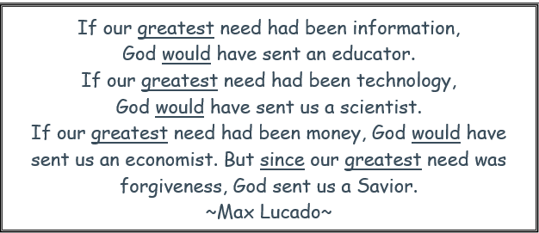

Bless others with Love
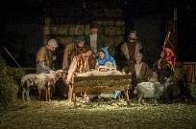
But when the set time had fully come, God sent his Son, born of a woman, born under the law, to redeem those under the law, that we might receive adoption to sonship. (Galatians 4:4-5)

God loved us so much that He stepped out of Heaven and into our world, to share with us in our lives. Imagine Heaven in all its splendour, Jesus left all that and came into our dusty and hard human lives.

This is how we know what love is: Jesus Christ laid down his life for us. And we ought to lay down our lives for our brothers and sisters. If anyone has material possessions and sees a brother or sister in need but has no pity on them, how can the love of God be in that person? Dear children, let us not love with words or speech but with actions and in truth. (1 John 3: 16-18)

Experience God's Love
See what great love the Father has lavished on us, that we should be called children of God! And that is what we are! The reason the world does not know us is that it did not know him. (1 John 3:1)
We are not guest in God's house. We are His children and thus the host. We are to welcome and make others feel at home. We are to show others God’s Love.

What or where is God's house?
It's being in God's presence daily. A consistent walk with God and remaining in His presence.

How is the Love of the Father channelled in your life?
We love because he first loved us. (1 John 4:19)
When we walk in with God, we will know His love for us and thus we are able to love others.

And so we know and rely on the love God has for us. God is love. Whoever lives in love lives in God, and God in them. (1 John 4:16 NIV)

We know it so well, we’ve embraced it heart and soul, this love that comes from God. (1 John 4:16 The Message)

Conclusion
We are all familiar with 1 Corinthians 13 which talks about Love, let us take a look at a Christmas Version of this text.

1 Corinthians 13—Christmas Version
If I decorate my house perfectly with plaid bows, strands of twinkling lights, and shiny balls; but do not have love, I’m just another decorator.

If I slave away in the kitchen, baking dozens of Christmas cookies, preparing gourmet meals, and arranging a beautifully adorned table at mealtime; but do not have love, I’m just another cook.

If I work at a soup kitchen, carol in the nursing home, and give all that I have to charity; but do not have love, it profits me nothing.

If I trim the spruce with shimmering angels, and crocheted snowflakes, attend a myriad of holiday parties, and sing in the choir’s cantata; but do not focus on Christ, I have missed the point.

Love stops the cooking to hug the child. Love sets aside the decorating to kiss the spouse. Love is kind, though harried and tired. Love does not envy another’s home that has coordinated Christmas china and table linens. Love does not yell at the kids to get out of the way, but is thankful they are there to be in the way.

Love does not give only to those who are able to give in return, but rejoices in giving to those who cannot. Love bears all things, believes all things, hopes all things, and endures all things. Love never fails.

Toys will break, pearl necklaces will be lost, golf clubs will rust; but giving the gift of love will endure.

Sermon summary by Prudence

