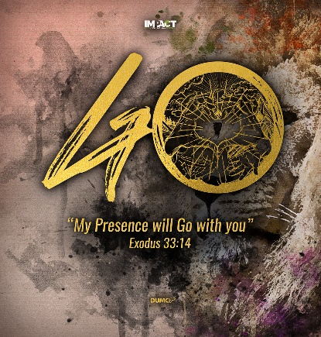
Jonah - Running from God - Boundless Compassion
Senior Pastor Chris Kam
The word of the Lord came to Jonah son of Amittai: “Go to the great city of Nineveh and preach against it, because its wickedness has come up before me.” But Jonah ran away from the Lord and headed for Tarshish. He went down to Joppa, where he found a ship bound for that port. After paying the fare, he went aboard and sailed for Tarshish to flee from the Lord. Then the Lord sent a great wind on the sea, and such a violent storm arose that the ship threatened to break up. All the sailors were afraid and each cried out to his own god. And they threw the cargo into the sea to lighten the ship. But Jonah had gone below deck, where he lay down and fell into a deep sleep. The captain went to him and said, “How can you sleep? Get up and call on your god! Maybe he will take notice of us so that we will not perish.” Then the sailors said to each other, “Come, let us cast lots to find out who is responsible for this calamity.” They cast lots and the lot fell on Jonah. So they asked him, “Tell us, who is responsible for making all this trouble for us? What kind of work do you do? Where do you come from? What is your country? From what people are you?” He answered, “I am a Hebrew and I worship the Lord, the God of heaven, who made the sea and the dry land.” This terrified them and they asked, “What have you done?” (They knew he was running away from the Lord, because he had already told them so.) The sea was getting rougher and rougher. So they asked him, “What should we do to you to make the sea calm down for us?” “Pick me up and throw me into the sea,” he replied, “and it will become calm. I know that it is my fault that this great storm has come upon you.” Instead, the men did their best to row back to land. But they could not, for the sea grew even wilder than before. Then they cried out to the Lord, “Please, Lord, do not let us die for taking this man’s life. Do not hold us accountable for killing an innocent man, for you, Lord, have done as you pleased.” Then they took Jonah and threw him overboard, and the raging sea grew calm. At this the men greatly feared the Lord, and they offered a sacrifice to the Lord and made vows to him. (Jonah 1:1-16)

Introduction
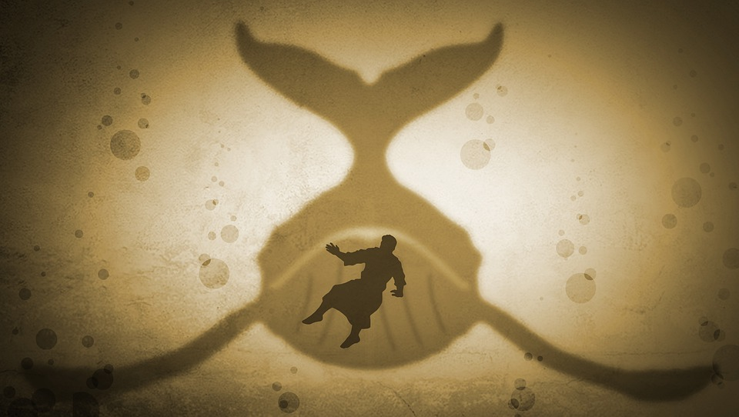
The book of Jonah gives us a reflective study on God’s character - of His grace and mercy; it is a story about disobedience and repentance; and contains 8 recorded miracles. It is not a fable. Jesus himself mentioned about Jonah.
Then some of the Pharisees and teachers of the law said to him, “Teacher, we want to see a sign from you.” He answered, “A wicked and adulterous generation asks for a sign! But none will be given it except the sign of the prophet Jonah. For as Jonah was three days and three nights in the belly of a huge fish, so the Son of Man will be three days and three nights in the heart of the earth. (Matthew 12: 38-40)
Jonah was like Christ in the sense that he went through the cycle of ‘death, burial and resurrection’.

Jewish people celebrate Yom Kippur, also known as the Day of Atonement. During their services, the story of Jonah is always read out as a reminder that the Jewish people will put themselves aside for the benefit of others. That the church of Israel will be the light of the world and be a blessing to the nations. This points back to the Abrahamic Covenant:
“... and all peoples on earth will be blessed through you.” (Genesis 12:3b)
God’s call to Jonah, is as relevant today, as it was back then. Preach the gospel that people may repent.
The word of the Lord came to Jonah son of Amittai: “Go to the great city of Nineveh and preach against it, because its wickedness has come up before me.” (Jonah 1:1-2)
The possibilities of Jonah running away from God:
- The Ninevites were cruel people and Jonah hated them. So, when God called him to preach to the Ninevites, Jonah reacted with bigotry in his heart.
- He had a bad past experience. As a prophet, Jonah went up to King Jeroboam II to tell the latter to repent. Instead the king became worst and extended his borders. Jonah did not want the same outcome for Nineveh.
Topics that will be covered on the book of Jonah:
God has been calling us to Go. As it has been preached previously, God’s presence will go with us wherever He wants us to go.
The Lord replied, “My Presence will go with you, and I will give you rest.” (Exodus 33:14)
BIG IDEA: When God Says “Go”, don’t say “No”.
Why would we say “No”? Well, It could be due to rebelliousness, us being lost, or we may have back-slided. When God says “Go” and you say “No”, God grabs your attention, desires your awakening towards genuine repentance.

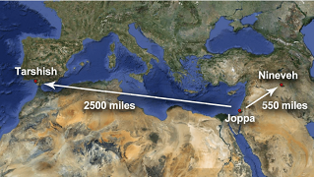
Grabs Your Attention
Instead of heading towards Nineveh,
Jonah ran away from the Lord and headed for Tarshish. He went down to Joppa, where he found a ship bound for that port. After paying the fare, he went aboard and sailed for Tarshish to flee from the Lord. (Jonah 1:3)

Just because there are open doors, it does not mean that it is God’s door.
There are 5 things that can happen when you are running from God:

Sends a storm
Then the Lord sent a great wind on the sea, and such a violent storm arose that the ship threatened to break up. (Jonah 1:4)
God himself may send storms likes challenges and adversities to teach (not necessarily to punish) us. We should have a deep trust in Him. We shouldn’t be asking Him, “Why is this happening?” but rather, “What are you trying to tell me through this experience?”

Stirs up people around you
All the sailors were afraid and each cried out to his own god. And they threw the cargo into the sea to lighten the ship. (Jonah 1:5)
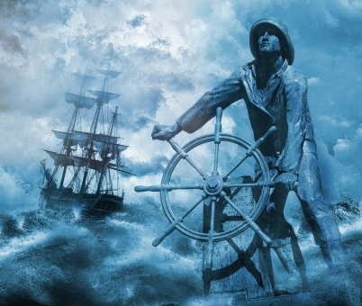
Our sins and disobedience will affect others, whether intentionally or unintentionally. We can drag others into the storms that we are going through.

Sends someone to you
The captain went to him and said, “How can you sleep? Get up and call on your god! Maybe he will take notice of us so that we will not perish.” (Jonah 1:6)
Oftentimes, many people’s response to another person’s correction is anger. Learn to be in humility and be thankful that someone cared and loved us enough to correct us.

Exposes our sins / disobedience
Then the sailors said to each other, “Come, let us cast lots to find out who is responsible for this calamity.” They cast lots and the lot fell on Jonah. So they asked him, “Tell us, who is responsible for making all this trouble for us? What kind of work do you do? Where do you come from? What is your country? From what people are you?” (Jonah 1:7-8)
God singled out Jonah. He will expose you because He loves you.

Intervenes physically
Then they took Jonah and threw him overboard, and the raging sea grew calm. (Jonah 1:15)
This could be scary, as it can happen as a trajectory of sin.
“Pick me up and throw me into the sea,” he replied, “and it will become calm. I know that it is my fault that this great storm has come upon you.” (Jonah 1:12)
This could be the turning point when Jonah admitted that it was his fault.
Like him, we need to take personal responsibility over our own lives.

Desires Your Awakening
Endure hardship as discipline; God is treating you as his children. For what children are not disciplined by their father? They disciplined us for a little while as they thought best; but God disciplines us for our good, in order that we may share in his holiness. No discipline seems pleasant at the time, but painful. Later on, however, it produces a harvest of righteousness and peace for those who have been trained by it. (Hebrews 12:7,10-11)

God wants us back to be in fellowship with Him
Sin will break the fellowship we have with God. When we sin, God grieves. He wants us back. Problems will force us to our knees.
He answered, “I am a Hebrew and I worship the Lord, the God of heaven, who made the sea and the dry land.”(Jonah 1:9)
Here, in verse 9, Jonah makes a declaration of who he is and who God is.

God wants us to acknowledge our sins
This terrified them and they asked, “What have you done?” (They knew he was running away from the Lord, because he had already told them so.) (Jonah 1:10)
When we admit and confess our sins with one another, it is no longer a secret. Why would we want to carry a burden in our hearts, sometimes for years? When a sin is no longer a secret, we can live a more free and blessed life.
Therefore confess your sins to each other and pray for each other so that you may be healed. The prayer of a righteous person is powerful and effective. (James 5:16)
Ponder:
If you are asked, “What sins have you committed since we last met?”, what would your respond be?

God wants us to submit to His will
“Go to the great city of Nineveh and preach against it, because its wickedness has come up before me.” (Jonah 1:2)
What is the ‘Nineveh’ in your life? It could be a task or it could be about ourselves, the community, or the mere act of sharing the gospel with someone.
Then the word of the Lord came to Jonah a second time: “Go to the great city of Nineveh and proclaim to it the message I give you.” (Jonah 3:1-2)
God repeated His will to Jonah. He will pursue and he won’t let you go until you submit to His will.

Towards Genuine Repentance
This point will be covered in the following sermon. It is about the process of repentance, while Jonah was in the belly of the big fish.
Now the Lord provided a huge fish to swallow Jonah, and Jonah was in the belly of the fish three days and three nights. From inside the fish Jonah prayed to the Lord his God. (Jonah 1:17 - 2:1)

Conclusion
During the torch relay for the 1996 Atlanta Olympics, cyclist Harley Sheffield’ was riding on the Tacoma Narrows Bridge when his bicycle tire burst, and he fell down. The torch broke and the fire extinguished. Then, a spare torch with the Olympic "mother flame," was taken out of the van that was pacing the torchbearers. The flame continued to make its way to the main Olympic cauldron in Atlanta.
Similarly, we may trip and fall out of alignment with God. Our flames may flicker slowly and snuffed out. However, the Holy Spirit carries the eternal flame and can light up the flame within us again so that we may continue to be on fire and run this race to the end.

Sermon summary contributed by Wendy ML Tan

