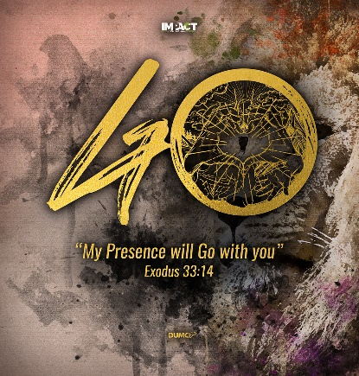
Jonah - Boundless Compassion 2
(Jonah 1:7 – 2:1-10)
Senior Pastor Chris Kam

Now the Lord provided a huge fish to swallow Jonah, and Jonah was in the belly of the fish three days and three nights. From inside the fish Jonah prayed to the Lord his God. He said: “In my distress I called to the Lord, and he answered me. From deep in the realm of the dead I called for help, and you listened to my cry. You hurled me into the depths, into the very heart of the seas, and the currents swirled about me; all your waves and breakers swept over me. I said, ‘I have been banished from your sight; yet I will look again toward your holy temple.’ The engulfing waters threatened me, the deep surrounded me; seaweed was wrapped around my head. To the roots of the mountains I sank down; the earth beneath barred me in forever. But you, Lord my God, brought my life up from the pit. “When my life was ebbing away, I remembered you, Lord, and my prayer rose to you, to your holy temple. “Those who cling to worthless idols turn away from God’s love for them. But I, with shouts of grateful praise, will sacrifice to you. What I have vowed I will make good. I will say, ‘Salvation comes from the Lord.’” And the Lord commanded the fish, and it vomited Jonah onto dry land. (Jonah 1:17-2:10)

Introduction

If you go to Israel today, there are reminders of Jonah.
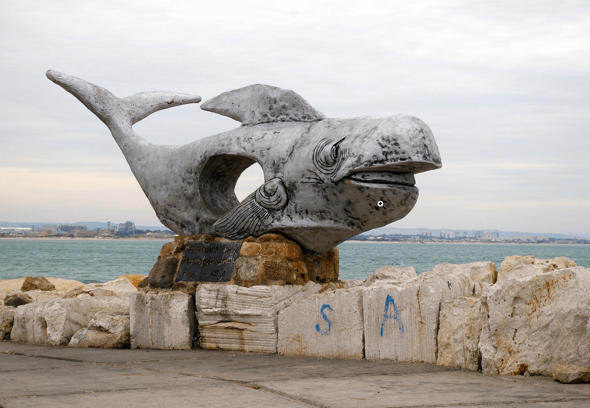
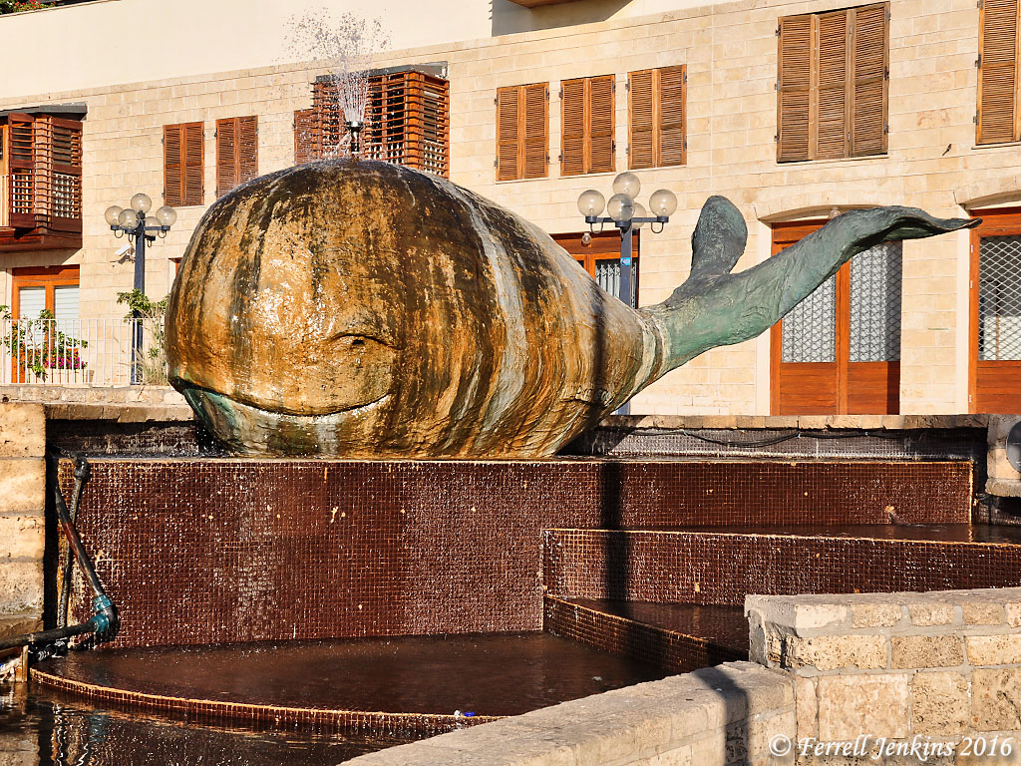

Jaffa (Joppa)
Tel Aviv, Israel
Port of the old city of Akko (Acre)
Israel

Call of God to Jonah (Jonah 1:1-2)

The word of the Lord came to Jonah son of Amittai: “Go to the great city of Nineveh and preach against it, because its wickedness has come up before me.” (Jonah 1:1-2)
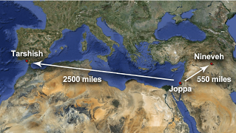
However, instead of going northeast to Nineveh which is 550 miles away, Jonah went to Tarshish, the furthest point away in the known world then, which was 2,500 miles away.

When God says ‘go’, do not say ‘no’.

When we say ‘no’, things happen to us because God loves us so much that He wants to be able to discipline us in such a way that we get right back to the will of God because that is the best plan for our lives.

There are four chapters in the book of Jonah.

Jonah 1 – 4
Running from God (Jonah 1)
Running to God (Jonah 2)
Running with God (Jonah 3)
Running ahead of God (Jonah 4)

In these four kinds of people, which category are you in? God is a loving God, He will continue to work in our lives and want us to run with Him. That is His desire, that while we are on earth, we run with Him.

BIG IDEA: God is not finished with me yet!

As long as we are on this earth, God will continue to work in our lives, because He wants us to walk in the centre of His will. The story of Jonah is the story of salvation. It is a story of rebellion, repentance and redemption.

Rebellion

Now the Lord provided a huge fish to swallow Jonah, and Jonah was in the belly of the fish three days and three nights. (Jonah 1:17)

Interestingly, it says in this verse that it is the Lord Who provided a big fish for Jonah. Jonah was dying and drowning and God provided a huge fish to swallow Jonah to save him. Even though Jonah wanted to run away from God, we can never ever run away from God. We will always be in the presence of God whether we realise it or not. God loves us so much and wants to get our attention. How many of us are in the belly of a fish right now, desperate and crying out to God?
Jonah can be said to be quite a selfish person, only caring about his own people. When he was called to preach to the Ninevites, he questioned God why he should be preaching to such cruel people. He is self-righteous and bigoted to think that only he deserves God. Are we like that too? Many of us need to repent of this.

While on the ship, Jonah was actually rebellious as he was running away from God.

“I am a Hebrew and I worship the Lord, the God of heaven, who made the sea and the dry land.” (Jonah 1:9)

Jonah made this statement while he was running away from God. This may sound like many of us: we may be living in disobedience but we say that we are Christians. It does not make sense when we say we are followers of Jesus but we are not walking like Jesus. God dealt with Jonah on that and God will deal with us on that too.

We mess up because we do not know what God says in His word. We need to go to the Word of God that will instruct the way we live our lives. We miss out on the goodness of God when we do not read the Word of God.

The Centre for Bible Engagement conducted a research entitled “Bible Engagement as the Key to Spiritual Growth: A Research Synthesis”, which was conducted over eight years where they surveyed over 100,000 people from around the world, on how the Bible affects us.

It was found that if people read the Bible once a week, nothing changed. If people read the Bible twice a week, nothing much happened too. When people read the Bible three times a week, something happened.

The turning point comes when people read the bible four times a week, as things began to happen.

Some findings of the research is as reproduced below:

Bible reading at least 4 times a week

Drop rate
- Feeing lonely – 30%
- Anger issue – 32%
- Bitterness in relations – 40%
- Alcoholism – 62%
- Pornography – 59%
- Feeling spiritually stagnant – 60%
Jump rate
- Sharing faith – 228%
- Discipling others – 231%
- Tithe/Offering – 416%

Why are people moving their lives in rebellion? Because they do not know what God has said in their hearts. Ignorance is not an excuse.

I have hidden your word in my heart that I might not sin against you. (Psalm 119:11)

One of the reasons why people sin is because they do not have the Word of God in their heart.

Here’s the challenge: read the Word of God every day.

Repentance

Acknowledgement of our vulnerability – cry for help
Jonah realise that he’s weak and he’s not in control. Some of us needs to be in the belly of a fish in order to cry out to God.

From inside the fish Jonah prayed to the Lord his God. He said: “In my distress I called to the Lord, and he answered me. From deep in the realm of the dead I called for help, and you listened to my cry. (Jonah 2:1-2)

We are not sure if Jonah really died, or if he almost died. Sometimes we need to hit rock bottom in our lives in order for us to cry out to God. When times are good, we need to learn the Word of God and not to stray from Him to rebellion. Jonah acknowledged that he’s weak and he needs God.

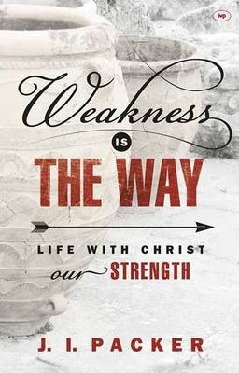
The sailors were lost and did not know what to do. Sometimes it’s good to be reminded what it means to be lost, to be without hope. Otherwise, we become very judgemental and self-righteous. We must remain completely dependent on our Lord Jesus. In the book of John, we are reminded that apart from Him, we can do nothing.

JI Packer wrote the book “Weakness is the Way”. He discovered that the greatest triumph in his life is when he is at his weakest. God is telling Jonah that he needs Him as much as the Ninevites need Him.

Acceptance of God’s Discipline
If God loves me, He will discipline me.

You hurled me into the depths, into the very heart of the seas, and the currents swirled about me; all your waves and breakers swept over me. (Jonah 2:3)
Do not be disappointed when problems come into our lives because God may have allowed that, although others may be causing it. God is in complete control of the entire universe.

And have you completely forgotten this word of encouragement that addresses you as a father addresses his son? It says, “My son, do not make light of the Lord’s discipline, and do not lose heart when he rebukes you, because the Lord disciplines the one he loves, and he chastens everyone he accepts as his son.” Endure hardship as discipline; God is treating you as his children. For what children are not disciplined by their father? If you are not disciplined—and everyone undergoes discipline—then you are not legitimate, not true sons and daughters at all. Moreover, we have all had human fathers who disciplined us and we respected them for it. How much more should we submit to the Father of spirits and live! They disciplined us for a little while as they thought best; but God disciplines us for our good, in order that we may share in his holiness. No discipline seems pleasant at the time, but painful. Later on, however, it produces a harvest of righteousness and peace for those who have been trained by it. (Hebrews 12:5-11)

No one likes discipline. In the discipline, there are four responses to God.

Four Responses to Discipline

Make light of it
We ignore the discipline.

… My son, do not make light of the Lord’s discipline, (Hebrews 12:5)

We ought to take it seriously what God is doing in our lives.

Lose heart and become discouraged
… and do not lose heart when he rebukes you, (Hebrews 12:5)

Resist it and invite greater discipline
If you resist God, you will invite greater discipline.

If you are not disciplined—and everyone undergoes discipline—then you are not legitimate, not true sons and daughters at all. Moreover, we have all had human fathers who disciplined us and we respected them for it. How much more should we submit to the Father of spirits and live! (Hebrews 12:8-9)

God will discipline you like how a father and mother will discipline their children for their good.

Endure and grow in righteousness and peace
No discipline seems pleasant at the time, but painful. Later on, however, it produces a harvest of righteousness and peace for those who have been trained by it. (Hebrews 12:11)

Do not pray away hardship in our lives because God will use that to train us.

Affix our Eyes on God again
I said, ‘I have been banished from your sight; yet I will look again toward your holy temple.’ (Jonah 2:4)

‘Yet’ here means it will come but has not yet come.

“When my life was ebbing away, I remembered you, Lord, and my prayer rose to you, to your holy temple. (Jonah 2:7)

Abiding in God’s Will
“Those who cling to worthless idols turn away from God’s love for them. But I, with shouts of grateful praise, will sacrifice to you. What I have vowed I will make good. I will say, ‘Salvation comes from the Lord.’” (Jonah 2:8-9)

It was God who sent a big fish to swallow Jonah up to save him and only then did Jonah come out of his rebellion.

Many of us want to be in control. However, we have no control whatsoever. But God is. The more we want to be in control, the less we are in control.

But it does not mean we do not plan. Scripture says that man plans, but the Lord directs His step.

Redemption

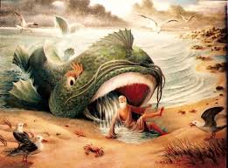
And the Lord commanded the fish, and it vomited Jonah onto dry land. (Jonah 2:10)

This is the entire salvation plan of God: from rebellion, God brings us to repentance, and finally to redemption.

For as Jonah was three days and three nights in the belly of a huge fish, so the Son of Man will be three days and three nights in the heart of the earth. (Matthew 12:40)

Jonah was a type of Christ. Jonah is a depiction of what God will do. God will pursue you. God is not finished with you yet.

…being confident of this, that he who began a good work in you will carry it on to completion until the day of Christ Jesus. (Philippians 1:6)

Do not think that we come to Christ through our own volition. God is the one who started it, He will carry it through and He will complete it. It is not us. God wants to pursue us.

There was a poet named Francis Thompson. He wrote a poem entitled ‘The Hound of Heaven’, where is trying to say God is like the hound of heaven. He wrote this 182-lined poem in 1893 when he was 34 years old, and the poem became famous. J.R.R Tolkien, who wrote ‘The Lord of the Rings’ and C.S. Lewis, who wrote ‘The Chronicles of Narnia’, just two of the many people, were amazed at the poem. Tolkien even presented a paper on ‘The Hound of Heaven’.
Published 1893
Francis Thompson
1859 – 1907
English Poet

Thompson was quite a messed-up person. His parents wanted him to become a doctor but he ended up being a poet. He ended up very poor although he came from a good family. His life was punctuated with sorrow, failure and drug addiction. He died young at the age of 48 years old. He wrote this poem while going through difficulties in his life, because he knew God will not give up on Him. He wrote this poem based on the British tradition of hare-crossing, where two dogs are released to chase a hare. God will pursue you and pursue you until He gets you. This is the kind of God that we have.

The following are eight lines from the poem:

The Hound of Heaven

¹ I fled Him down the nights and down the days
² I fled Him down the arches of the years
³ I fled Him down the labyrinthine ways
⁴ Of my own mind, and in the midst of tears

¹⁷⁹ Shade of His hand, outstretched caressingly?
¹⁸⁰ Ah, Fondest, Blindest, Weakest,
¹⁸¹ I am He whom thou seekest.
¹⁸² Thou dravest Love from thee who dravest Me.

Thompson wrote this at a time when he was at the bottom of the sea. He fled god because of the rebellion in his life. In his most difficult time, he realised that God never gave up on him.

God will pursue you no matter the condition of your heart, because He has a plan for your life. Do not miss out on God’s plan for your life. Chase that lion.

“”You cannot run away from the truth because truth will find you”
~ColoZeus Benz

Sermon summary contributed by May

