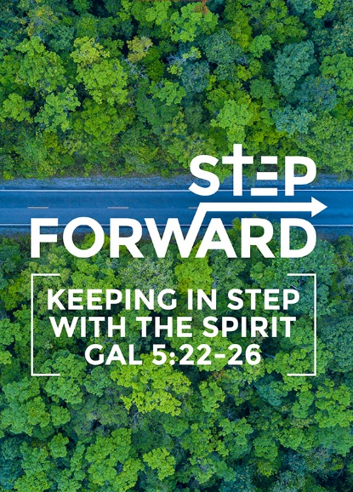
Christian Citizenship - Church & Politics, Religious Freedom & Persecution
Founding Senior Pastor, Dato’ Dr Daniel Ho
“Everyone must submit himself to the governing authorities,for there is no authority except that which God has established. The authorities that exist have been established by God. Consequently, he who rebels against the authority is rebelling against what God has instituted, and those who do so will bring judgment on themselves. For rulers hold no terror for those who do right,but for those who do wrong. Do you want to be free from fear of the one in authority? Then do what is right and he will commend you.For he is God's servant to do you good. But if you do wrong, be afraid, for he does not bear the sword for nothing. He is God's servant, an agent of wrath to bring punishment on the wrongdoer. Therefore, it is necessary to submit to the authorities, not only because of possible punishment but also because of conscience. This is also why you pay taxes, for the authorities are God's servants, who give their full time to governing. Give everyone what you owe him: If you owe taxes, pay taxes; if revenue, then revenue; if respect, then respect; if honor, then honor. (Romans 13:1-7)

Introduction
Everything is political but not everything is politics. You may not be interested in politics, but politics is interested in you, your children and your grandchildren.

What is politics?
It is about the art of governance of the affairs of the state / nation. It is about running the country. It should not be left to politicians, but citizens should contribute too.


A right understanding of politics
A right understanding leads to a right undertaking. It is not a time for politicians to benefit themselves. A right reasoning leads to a right response. Politics is the highest form of public service because it involves serving the people and the nation. It is not just certain groups of people, but everyone.

The role of the Church / Christians in the nation

To pray
- Never underestimate the power of prayer to intercede for the nation / land.
I urge, then, first of all, that requests, prayers, intercession and thanksgiving be made for everyone - for kings and all those in authority, that we may live peaceful and quiet lives in all godliness and holiness. (1 Timothy 2:1, 2)

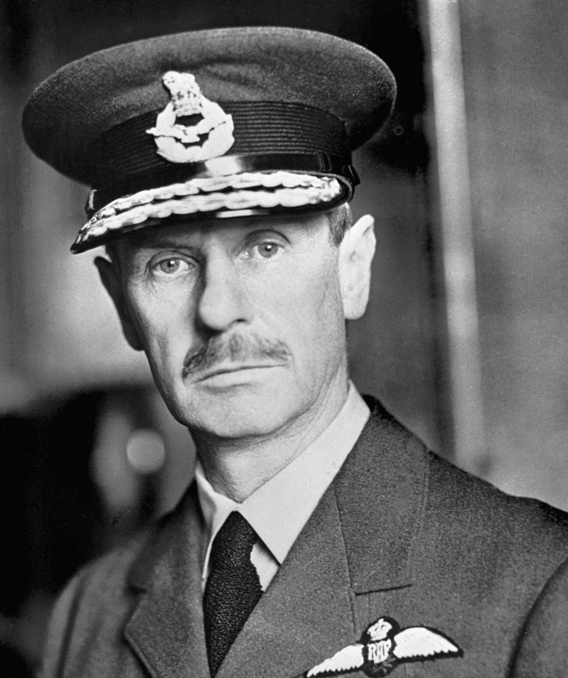
A fine example of a man who prayed for his nation was Air Chief Marshal Lord Dowding, Commander in-Chief of the British Royal Air Force. During WW2, even though Britain has lost the war, miraculously one morning, the German air force, Luftwaffe, turned back and flew back East, giving Britain its victory in the Battle of Britain. Lord Dowding acknowledged God for the win.

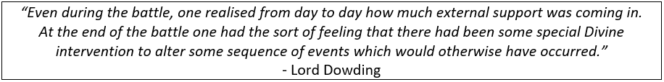

To submit
Everyone must submit himself to the governing authorities, for there is no authority except that which God has established. The authorities that exist have been established by God. … Therefore, it is necessary to submit to the authorities, not only because of possible punishment but also because of conscience. (Romans 13:1, 5)
We need to submit so that the country can function properly and orderly and people can live in peace and harmony. However, we must be careful not to blindly submit, as the authority in power tend to abuse power and position. When we do not speak out against what is right or wrong, the end will come.

“Our lives begin to end the day we become silent about things that matter.” - Martin Luther King Jr.

The ultimate measure of a man is not where he stands in moments of comfort and convenience, but where he stands at times of challenge and controversy.”- Martin Luther King Jr.

To serve people and country
For rulers hold no terror for those who do right, but for those who do wrong. Do you want to be free from fear of the one in authority? Then do what is right and he will commend you….. Give everyone what you owe him: If you owe taxes, pay taxes; if revenue, then revenue; if respect, then respect; if honor, then honor. (Romans 13:3,7)

The authorities are to ensure that right-doing is encouraged and affirmed, while wrongdoing is punished. We do what is right because we are put here by God so get involved in building, supporting, praying and contributing towards the good of the nation. We should break out from our Christian ghetto and be involved in serving everyone. Yet, the church sometimes get misunderstood and authorities are out to terrorise the church.

“A state which includes within itself a terrorised church has lost its most faithful servant.”
- Dietrich Bonhoeffer.

The church should be the greatest friend and ally, and not a threat, to the country. We are transformed people to spearhead the transformation of the nation. We can also be a prophetic voice to the nation

To speak truth to power
How can the church be involved in politics? Is it okay?

Let’s refer to the Bible. In the Bible, we read that
- Prophets confronted kings
"You acted foolishly," Samuel said. "You have not kept the command the Lord your God gave you; if you had, he would have established your kingdom over Israel for all time.” (1 Sam 13:13)
- Jesus seldom talked about politics because his bigger mission was the salvation of the nations. Often, he did not confront the authorities, but he did when he needed to.
He replied, "Go tell that fox, 'I will drive out demons and heal people today and tomorrow, and on the third day I will reach my goal.' (Luke 13:32)
Jesus answered, "You would have no power over me if it were not given to you from above. Therefore the one who handed me over to you is guilty of a greater sin." (John 19:11)\

Show proper respect to everyone: Love the brotherhood of believers, fear God, honor the king. (1 Peter 2:17)

In the world, it is often the case where people honour God and fear the king but the Bible reminds us that the “Fear of man will prove to be a snare.” (Proverbs 29:25a)

“I believe that unarmed truth and unconditional love will have the final word in reality. This is why right, temporarily defeated, is stronger than evil triumphant.” - Martin Luther King Jr.

“There comes a time when one must take a position that is neither safe nor politic nor popular, but he must take it because his conscience tells him it is right.” - Martin Luther King Jr.
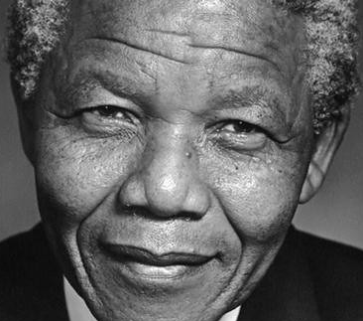
“For those who would continue to participate, politics went from being a risky occupation to a truly perilous one… The children of a freedom fighter also learn not to ask their father too many questions, and I could see in their eyes that they understood that something serious was occurring”
- Nelson Mandela, A Long Walk to Freedom. He fought against apartheid regime in South Africa, and was imprisoned for 27 years.

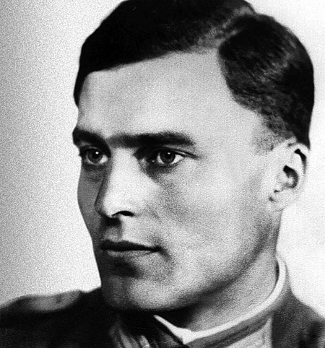
Having escaped 16 attempted assassination against him, Hitler could have tapped into some power. Hitler was an embodiment of evil. Even in his army, was a man named Lieutenant colonel Claus Schenk von Stauffenberg who plotted to assassinate Hitler as well.

Prior to the attempt, Claus Schenk said,
“It’s time now for something to be done. He who has the courage to act must know that he will probably go down in German history as a traitor. But if he fails to act, he will be a traitor before his own conscience.”

The role of the State in the nation
A government consists of

The legislature which is the parliament.

The executive branch, that is the ones in power to run the affairs of the State and

The judiciary who are the judges and the law of order.

It is important to have different components that act as check-and-balance for one another.

The roles of the State (the Executives):

As God’s servant
For he is God's servant to do you good. But if you do wrong, be afraid, for he does not bear the sword for nothing. He is God's servant, an agent of wrath to bring punishment on the wrongdoer. This is also why you pay taxes, for the authorities are God's servants, who give their full time to governing (Romans 13:4, 6)
‘God’s servant’ appeared 3 times in this text. We are accountable to God. Therefore, we should serve His plans and not for ourselves. God knows and sees everything. The State is accountable to us too because we put them in power.

As purveyor of law and order
For rulers hold no terror for those who do right, but for those who do wrong. Do you want to be free from fear of the one in authority? Then do what is right and he will commend you. (Romans 13:3)

Sadly, when a ruler becomes a terror to those who do right, they will lose their power and authority.

“The Church must continually ask the state whether its action can be justified as legitimate action of the state, that is as action which leads to law and order, and not to lawlessness and disorder.” ~Dietrich-Bonhoeffer

We need to have the discernment and understanding to speak out on what should be done. Also, when am atmosphere of “excessive law and order” is created, it is the business of Christians, and the Church to remind those in authority likewise.

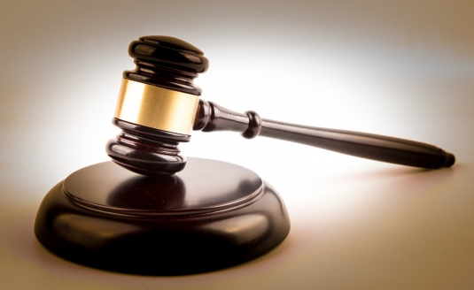
As a bastion of truth, justice and righteousness
We should stand for what is right, true, just and fair. If it is not right, then we should ask for forgiveness and repent. We should have a conducive manner in business, education, law and order that we may live freely.

Reasons for the rights of every person in a nation
- It is theological because of the way human beings are created
So God created man in his own image, in the image of God he created him; male and female he created them. (Gen 1:27)
All of us have worth, value and dignity and should be treated with respect.

- These unalienable rights are intrinsic to us as human beings and not conferred upon by the state (cf. Acts 16:37-39)
Some of the rights include the rights to have education, ownership of property, peaceful assemblies, religious freedom to worship.

“First they came for the Socialists, and I did not speak out - because I was not a Socialist. Then they came for the Trade Unionists, and I did not speak out - because I was not a Trade Unionist. Then they came for the Jews, and I did not speak out - because I was not a Jew. Then they came for me - and there was no one left to speak for me.” ~Martin Niemöller

- But rights do have boundaries / perimeters as well. (cf Acts 19:38-41)

How should Christians respond when they suffer or are persecuted
There are 2 kinds of sufferings:
- Suffering as a result of our own sin/foolishness
If you suffer, it should not be as a murderer or thief or any other kind of criminal, or even as a meddler. (1 Peter 4:15)
- Suffering for the sake of being faithful to Christ
However, if you suffer as a Christian, do not be ashamed, but praise God that you bear that name. (1 Peter 4:16)


Don’t be surprised
Dear friends, do not be surprised at the painful trial you are suffering, as though something strange were happening to you. (1 Peter 4:12)

To rejoice in it
But rejoice that you participate in the sufferings of Christ, so that you may be overjoyed when his glory is revealed. (1 Peter 4:13)

Not to be ashamed but to praise God
However, if you suffer as a Christian, do not be ashamed, but praise God that you bear that name. (1 Peter 4:16)

Commit oneself to one’s faithful Creator
So then, those who suffer according to God's will should commit themselves to their faithful Creator. (1 Peter 4:19a)

To continue to do good. Don’t retaliate nor revenge, instead forgive.
and continue to do good (1 Peter 4:1b)

Fruit of Christian suffering

Great joy
But rejoice that you participate in the sufferings of Christ, so that you may be overjoyed when his glory is revealed. (1 Peter 4:13)

Blessedness
If you are insulted because of the name of Christ, you are blessed, for the Spirit of glory and of God rests on you. (1 Peter 4:14)

Hope of vindication
At the end of it all, God is going to step in, judge and put things right.
For it is time for judgment to begin with the family of God; and if it begins with us, what will the outcome be for those who do not obey the gospel of God? And, "If it is hard for the righteous to be saved, what will become of the ungodly and the sinner?" (1 Peter 4:17-18)

Conclusion
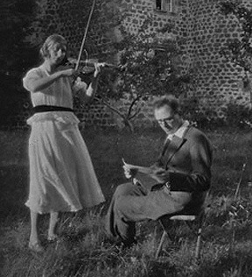
A French prisoner-of-war, Olivier Messiaen, was arrested by the Nazis during WWII and sent to a grim and chilly concentration camp in Silesia. While reading the gospel and book of Revelation, he felt a sense of hope was given to him and composed a song called Quartet for the End of Time. At the prison yard, he found a cello with broken strings, a beaten-up violin, a beaten-up clarinet and a bashed up piano with some keys glued together. When the song was played in the cold winter of January 1941, 5000 prisoners were rapt and attentive. That song gave them a sense of hope and a future too.

Someone wrote about Olivier Messiaen :
“Hope created meaning for the suffering people around him. In their appalling conditions he understood that hope for tomorrow was essential for life today. Those broken instruments in that unusual combination were unexpected agents of hope. Similarly, although we may feel inadequate and incomplete personal or spiritually, when we act together, God uses us to be agents of hope to the world. Things may fall apart, but when we stand together, we can offer hope. We have the hope of God. We are people who do not live with a hopeless end but an endless hope, in Jesus Christ.”

“This is the end. For me the beginning of life.” - Dietrich Bonhoeffer, 1906-1945
(His last word before he was executed)

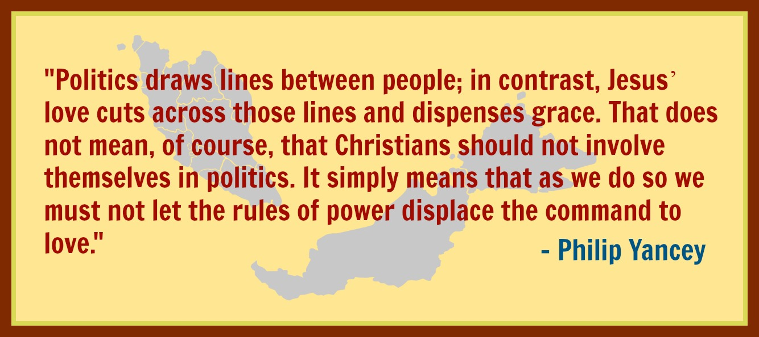

Sermon summary contributed Wendy ML.

